Models, measurement, and computer simulation: The changing face of experimentation
Margaret Morrison
Definitions:
Apparatus: Some kind of measuring device. In the pendulum example this is the pendulum itself. In the case of computer simulations this is the machine plus the program.
Simulation: A mathematical model of the target physical system (with some set of approximations) plus a numerical algorithm that is run as a computer program
Winsberg: the process of building, running, and inferring from computational models
Parker: a time ordered sequence of events that serves as a representation of some other time ordered sequence of events where the simulating system has certain properties that represents the properties of the target system.
Simulation system: Refers to the simulation model plus the program and computer it is run on
Simulation model: The mathematical model and set of approximations
Measurement: The process of acquiring knowledge of relevant parameters of a physical system. It typically involves some type of causal interaction with the material world via instruments. This will often involve the use of (sometimes hypothetical) models. In modern science, measurement is often indirect. In the case of simulation, measurement refers to the interpretation of large amounts of data with models.
Measurement theory: mappings from objects being studied to some numerical representation called a variable
Calculation: Mathematical activity involving abstract reasoning. In the case of simulation, calculation refers to the evolution of the model in temporal increments.
Standard definition: transformation of inputs into outputs
Model: General definition? In simulation, models are mathematical representations of a physical system.
Types of models include: Experimental models, models of the experiment, mechanical models, and mathematical models
Experiment: An activity that involves measurement. In the case of simulation, Morrison wants to say this goes beyond ‘numerical experiment:’ using numerical methods to find approximate solutions to mathematical models/equations that cannot be solved analytically.

Main argument: Certain types of computer simulations have the same epistemic status as experimental measurement
- The privileged status of experimental measurement is justified by appeals to materiality.
- The role of models in scientific measurement complicate the relationship between measurement and the material world. In modern science measurements are often indirect and rely on hypothetical models.
- Without this appeal to materiality, simulation is remarkably similar to experiment
- Therefore, when simulations meet certain requirements their results should share the epistemic status of experimental results.

Introduction
Observation: In recent years computer simulations have been used more intensively in fields such as astrophysics and climate science. Their use in these fields has evolved beyond simple ‘number crunching’ activities and they are instead used as tools for investigative research.
Question: Is this use of simulations as experiments merely pragmatic? Should we favor traditional experimental methods to simulation when traditional experiments are possible?
“What justifies an appeal to materiality in motivating an epistemic distinction between simulation and experiment and is there something significant about the access to material systems that renders experiments epistemically privileged?” (41).
Possible answers:
Gilbert and Troitzsch: the major difference between simulation and experiment is that in the latter one is controlling the actual object of interest while in a simulation one is experimenting with a model rather than the phenomenon itself.
Morgan: the materiality of experiments is an important feature in establishing external validity.
Parker: Intervention is what renders something an experiment. Simulation does not involve intervention in the real world and is therefore not an experiment.
Response:
Morrison: There are clear methodological distinctions between traditional experiments and simulations. However, we need to move to epistemic analysis to compare the status of the results produced by each method (42).
Additionally, simulations can be physically meaningful when their components correspond to components of the physical system in an appropriate way. This means they can be externally valid in the same way that traditional experiments are (46).
Each justification of the privileged epistemic status of experiments appeals to materiality. However, models are a crucial part of the measurement process and this 1) complicates the role of materiality in traditional experiments and 2) defines the experimental character of models themselves (48).
Models as measuring devices:
The pendulum example (49):
Say we want to measure gravitational acceleration using a simple plane pendulum.
We start with an ideal pendulum with a massless cord.
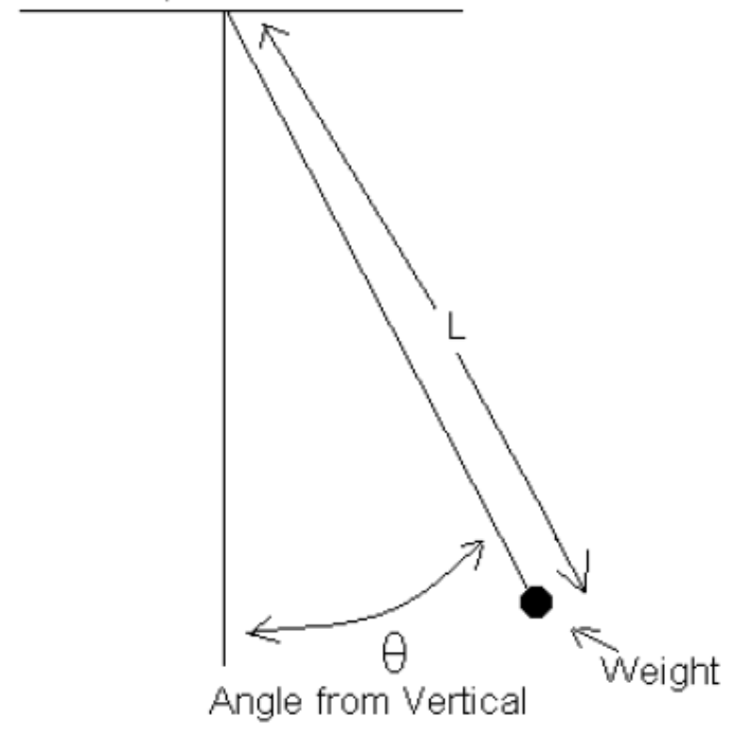
If we know the cord length and period we can solve for gravitational acceleration.
To find these we measure the physical apparatus (a real pendulum).
However, once these measurements are made on the physical apparatus, we need to make corrections using modeling assumptions and approximation techniques. Ex: finite amplitude corrections, elastic corrections due to wire stretching.
“…using the physical pendulum as an experimental apparatus requires us to have in place a very sophisticated model of that apparatus that renders it a measuring instrument” (49).
Discussion question: In this example do we want to say that we measure gravitational acceleration or that we calculate it?
Morrison: In modern physics virtually no measurements are tied to observing relations among physical objects.
“Many of the quantities we typically ‘measure’ are the products of indirect measurement or involve what is sometimes referred to as indirect variables” (51).
In the pendulum case, the measurement process is characterized by intervention with the model and its interplay with the physical system. This kind of experimental measurement is satisfied by simulations (52).
“Experimental measurement is a highly complex affair where appeals to materiality as a method of validation are outstripped by an intricate network of models and inference” (53).

Simulations as experiments
The process of simulation
- Start with a mathematical model of target physical system
- Apply appropriate discretizing approximations (this gives us the simulation model)
- Create the computer program with the simulation model and numerical algorithms
- Test and calibrate the program to ensure it reproduces the behavior of the target system in a reasonably accurate way
Simulations involve evolution in temporal increments called the timestep (DT).
In the case of simulations:
Calculation refers to the timestep cycle which generates a large amount of data.
Measurement refers to the stage at which we interpret this data using models.

 | Simulation | Pendulum
1. Model | Mathematical model of target system | The theoretical pendulum
2. Physical system | The target system | The physical (real) pendulum
3. Apply corrections | Apply discretizing approximations | Correct for measurements of physical pendulum
4. Calculate | Run computer program and interpret results with models | Solve for gravitational acceleration
5. Results | A measurement of the target system | A measurement of gravitational acceleration

Conclusions:
The ability of experiments to establish ontological and epistemic claims about physical phenomena “requires a complex network of modelling assumptions that are an inseparable part of experimental practice” (54)
“The appeal is not to materiality as the source of justification, but to the model of that materiality that best accounts for the data” (54).
Simulation is the same kind of activity as experimental measurement and thus it can produce results of the same epistemic status as traditional experiments.

Gems:
- Clear writing?
- Morrison’s argument has significant implications for fields that often receive little philosophical attention, such as astrophysics and climate science
- Her argument also forces us to reconsider foundational concepts in science such as measurement and experiment

- The article is structurally confusing. Terms are often not clearly defined and Morrison’s own views are sometimes obscured in extensive discussion of other people’s views.

