Z distribution practice problems

1. Given a normally distributed population with a mean of 75 and a standard deviation of 6, how likely is it that you could randomly draw a score less than 69?

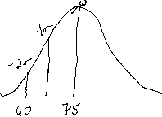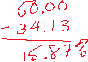

2. With a normally distributed population, mean = 125 and std. dev. = 12, how likely is it that you could randomly draw a score greater than 142?

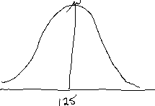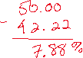

3. Using the parameters in #2, how likely is it that you could randomly draw a score between 110 and 129?

