1. Given a normally distributed population with a mean of 115 and standard deviation of 13, calculate the percent below a score of 130.

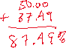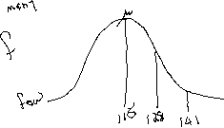

2. µ = 82, σ = 5.6. What percentage of the population scored below a 71?

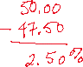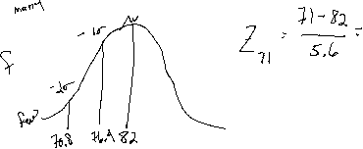

3. µ = 93, σ = 8. What percentage of the population scored between an 85 and 100?

