First draft: December 14, 2006
Second draft: April 17, 2007
Submitted: April 17, 2007

SBIR Phase I

Volumetric Airflow Gauge

Design team
Matthew Chakan
Justin Kiswardy
Michael Nilo

Advisor
Guy Guimond

Correspondence
Bioengineering Senior Design
Department of Bioengineering
749 Benedum Hall
University of Pittsburgh
Pittsburgh, PA 15261

Table of Contents

A. Introduction 3
B. Specific Aims 3
C. Background & Significance 5
D. Prior Work 6
E. Research Methods.......................................................................................................................7

F. Conclusion.................................................................................................................................16

G. Citations....................................................................................................................................17

A. Introduction

Individuals suffering from cardiopulmonary failure and other types of respiratory distress are commonly treated with a manual resuscitation device or bag-valve-mask (BVM) system in order to initiate breathing. Although the standard BVM system provides a versatile and light-weight alternative to CPR there are several primary drawbacks. The efficacy of resuscitation using a manual BVM is highly dependant on the training and skill level of the resuscitator using the device and, as a result, many potential complications exist; the most significant of which involve the over/under inflation of the patients’ airway. Well documented side-effects have been observed, including lung tissue damage, decreased lung compliance, gastric distension, and regurgitation. These side-effects frequently lead to co-morbidities involving increased hospital stay and cost incurred by the patient.

It has become apparent that a solution needs to be presented that would allow the user to better estimate and thereby control the amount of air that is introduced to the patients airway while using a manual BVM system. The project objective is to design a gauge that can be easily incorporated into such a resuscitation device, providing the user with a constant volumetric display of air introduced to the patient.

The volumetric airflow gauge will allow the user to more accurately determine the quantity of air being administered to the patient with each inflation/deflation cycle and make appropriate air flow adjustments accordingly. The device will potentially minimize the undesired side-effects associated with under/over inflation mentioned previously.

B. Specific Aims

Specific Aim I: Conceptually determine the most efficient method that is able to be utilized in order to directly measure the airflow volume expended from the BVM bag.

The final design of the volumetric airflow gauge (VAG) will be based primarily on the methodology used to measure the airflow volume. Therefore, the initial aim will be to determine this specific methodology. The theory behind various mass flow devices, volumetric gauges, and pressure gauges used in other applications will be analyzed. The optimal design for the VAG will take into account several factors including; efficiency, accuracy, size, weight, and safety to both the user and the patient. The design must be accurate to within 50ml of volume in order to minimize the effects of over/under inflation of the patients’ airway. In addition, the structure must minimize the weight and size impacts to a standard BVM system. Specifically, it must weigh less than ~100g and be able to be housed within a compact casing. Also, the design for the gauge must be safe to both the user and patient. Utilizing this set of parameters and requirements, an efficient gauge will be conceptually designed.

Specific Aim II: Determine an optimal design for the housing of the VAG, taking into account the VAG dimensions and requirements, standard BVM designs, ergonomics, and safety issues.
Prior to an initial housing or case design being constructed, a theorized model must be developed. The model will be purely conceptual and will take into account several factors determined to be relevant to the overall design including; the VAG dimensions, standard BVM designs, ergonomics, and safety issues. The proposed model will then allow for the further

development of a computer drawn prototype (specific aim III). First, the dimensions determined in the conceptual design of the VAG (specific aim I) will be incorporated into the housing. The case must properly house and protect the gauge as well as effectively display the volumetric reading to the user depending on the design determined in specific aim I. In addition, by analyzing current BVM designs, several dimension specifications will be determined regarding attachment points for the gauge to a manual resuscitator. Lastly, safety issues associated with the design of the case or housing will be taken into account in order to protect both the user and patient.

Specific Aim III: Construct a computer-aided prototype of the VAG including housing.

When the conceptual designs have been completed a computer-aided prototype will be developed using Solidworks software. The schematics will include dimensions of all parts intended to be included in the design. The computer generated prototype will be the first schematic of the VAG and will provide a better understanding of the limitations of the design.

Specific Aim IV: Manufacture a working prototype of the VAG based on the computer-generated schematics.

The prototype will be constructed utilizing materials that take into account the weight requirements of the design (specific aim II) along with the safety specifications. The housing will be manufactured using a stereolithography (SLA) process which will produce a resin mold from the Solidworks schematics. Depending on the design of the gauge (specific aim I), materials and fabrication techniques will be used as necessary and stated in research methods section. One prototype will be developed and will be used in order to conduct all subsequent verification and validation testing.

Specific Aim V: Submit the prototype to verification and validation testing in order to determine the accuracy, usability, and safety of the device.

First, tests will be performed in order to determine the accuracy of the device. A calibrated volumetric gauge built into a manikin (Laerdal) will be used to compare airflow volumes with the VAG. From this test the accuracy of the gauge may be determined. In addition, tests will be performed to determine the durability of the device. Lastly, the device will be subject to a field test, where individuals who are involved in the treatment and/or use of BVM systems will be given the opportunity to test the device under actual field conditions and comment on its features by responding to a survey.

C. Background & Significance

It is estimated that the United States 911 emergency call system handles 500,000 calls daily or ~183 million annually [1]. Of these calls, 35% are estimated to be related to cardio-pulmonary failure [4]. According to a study by Kuhns et. al, it may cost upwards of $2500 to send a qualified response team to a single call [2]. When a response team arrives to the field site the most commonly used practice for initiating breathing in a patient with cardiac arrest/ pulmonary failure, aside from CPR, is the use of a Bag-Valve-Mask (BVM) system. Since the late 1950’s, the BVM resuscitator, originally developed by Ambu, Inc. in Denmark, has been the mainstay of the healthcare provider for emergency ventilation of the patient in respiratory and/or cardiac arrest. Certainly, in the early days of CPR, these devices were the only available adjunct for the resuscitator. However, considering both the major advances made in medicine over the past 50+ years as well as the high first response costs mentioned above, it is remarkable that, for the most part, we are still relying on such dated technology to perform the task of re-oxygenation.

The American Heart Association requires that the BVM “must be comprised of the following: an oxygen/air reservoir to allow delivery of high concentration oxygen (bag), a nonrebreathing outlet valve that cannot be obstructed by foreign material and will not jam with an oxygen flow of 30 L/min; and the capability to function satisfactorily under common environmental conditions and extremes of temperature” [3]. A standard BVM device costs $10-50 and is typically sterilizable in an autoclave. The functionality of the BVM is based on providing positive-pressure ventilation to the patient. A one-way valve situated between the bag and mask permits air to flow from bag to patient while preventing flow in the opposite direction. An additional one-way valve is located on the opposite side of the bag that permits inflow of atmospheric air after the bag is compressed in order to re-inflate it. Although the standard BVM provides a versatile, lightweight, cost-effective alternative to CPR there are several key drawbacks as outlined below.

Due to the fact that the skill and training of the resuscitator alone determines the efficacy of resuscitation using a manual BVM, many potential complications exist. In fact, the American Heart Association clearly states that these devices were “generally ineffective in providing adequate ventilation”. One of the main drawbacks to the current model of the BVM is the lack of a volume gauge. Included in the guidelines for “Adult Basic Life Support” presented by the International Liaison Committee on Resuscitation (ILCOR), it is suggested that the resuscitator provide 400-600 ml air to an average adult size patient per cycle [5]. Without a proper volumetric gauge incorporated into the BVM, the recommended volume of air administered must be determined by on-site estimates of the resuscitator. As a result, potentially dangerous gas flow rates and pressure delivered to the patient have been well documented. Previous studies have shown lung tissue damage, decreased lung compliance, gastric distension, and regurgitation can all result from overly large tidal volume administration [3, 4, 6, 7, 8]. In addition, a number of these clinical studies have documented the inability, by highly skilled operators, to consistently deliver correct volumes without causing problems for the patient, some leading to increased morbidity and death. One study in particular indicated that as many as 40% of the patients treated through use of a BVM experienced gastric distension with 65% of those experiencing increased morbidity as a result. Using an independent flow monitor (VentcheckTM), Shepard et al. went on to show that the tidal volumes delivered to adults ranged from 200-1100ml, well outside of the recommended range [8]. Another study conducted by Wenzel et al., further developed a strategy to reduce air volume administered to patients. The study randomly selected 80 anaesthetized, apnoiec adults to receive ventilation with either a standard BVM (consisting of a bag volume ~1600ml) or a pediatric BVM (bag volume ~750ml). The results indicated that even experienced anaesthetists tended to exceed the recommended tidal volumes. As a result, five out of the 40 treated with the standard bag developed gastric distention and/or aspiration while none of the patients treated with the pediatric bag experienced undesired effects. While Wenzel’s investigation effectively eliminated the delivery of excessive tidal volumes, the design is impractical. There are specific cases in which a patient may require a significantly larger tidal volume and the pediatric BVM would fail. All of the studies mentioned above were conducted on adults and it should be noted that the effect of “over-inflating” is even more pronounced in resuscitation of infants and adolescents who have smaller lung capacities with more sensitive tissue properties.

Ideally, a completely automated system/device for in-field resuscitation could eliminate the problem of operators manually estimating volumes administered and, in fact, several have been proposed. However, although such a device may eliminate the “over-inflation” problem, these devices are cost prohibitive for scale-up production and are generally not lightweight/versatile. Therefore, the SBIR Phase I plan proposes the continued development of a volumetric gauge that may be incorporated into standard BVM’s, maintaining their desired features, while providing a much more accurate way to determine volumes administered to patients. The design, once completed, will potentially offer a cost-effective device that eliminates many undesired side effects currently experienced by patients during resuscitation. In addition, the improvement of in-field resuscitation should reduce morbidity rates, therefore, reducing hospital and/or patient costs.

D. Prior Work

Mr. Guy Guimond is serving as the primary investigator throughout the design and development process. Mr. Guimond currently serves as the Clinical Coordinator at the University of Pittsburgh Medical Center’s (UPMC) Center for Emergency Medicine. As Clinical Coordinator, Mr. Guimond manages all aspects of the prehospital & hospital clinical education for UPMC. In addition, he holds a faculty position teaching classes and labs for the paramedic program. Mr. Guimond has also performed significant research centered on CPR and emergency ventilation.

The Design Group consists of three undergraduate bioengineering students from the University of Pittsburgh. Through coursework, each of the students has extensive knowledge of relevant design software (Solidworks and COSMOS Floworks). The curriculum has also instilled good teamwork and quality presentation skills.

Justin Kiswardy is currently studying Biotechnology and Artificial Organ design at the University of Pittsburgh. Mr. Kiswardy has received a BS degree from Cornell University in business management. He has also completed an MBA essentials program through the University of Pittsburgh’s Katz business school. The program covered topics similar to those studied by traditional MBA students, in a condensed format. In addition, Mr. Kiswardy has conducted extensive research in Endocrinology at the University of Pittsburgh Medical School under the direction of Dr. Stephen O’Keefe. Mr. Kiswardy has been the coauthor on two journal articles reviewing his work on treating pancreatitis and colon cancer and has been asked to present his work at the annual Diet and Digestion conference, Los Angeles, CA in 2006. In addition, Mr. Kiswardy has conducted self-guided research in Plastic Surgery at UPMC. His work has involved the design and fabrication of guidance channels directed towards stimulating nerve growth. Currently, Mr. Kiswardy holds a position with Arthrex, a global orthopedic device company, in medical device sales. His experience in business management relating to the healthcare industry will provide valuable insight to the Design Team.

Matthew Chakan is currently studying Bioengineering with a concentration in the Biotechnology/Artificial Organs field. In addition, he has extensive experience with scientific research and device design and manufacture. He has coauthored three collaborative projects with other members of his laboratory team and has completed one independent project, while he is currently performing another. His experiences have produced multiple presentations in peer-reviewed, professional society meetings, although he is still involved in writing the manuscripts for the completed studies. His current independent project, though still in its infancy, has shown enough promise that he was awarded the competitive Kwok-Chong Woo Grant. In addition to his scientific abilities with experiments, he is also in charge of the Department of Orthopaedic Surgery, Research Lab Machine Shop, where he designs and builds the apparatuses used in experimentation. With experiences ranging from basic scientific ability to device design and manufacture, Mr. Chakan’s experiences should prove useful in designing and implementing solutions when developing the proposed volumeter.

Michael Nilo is currently studying Biotechnology/Artificial Organs at the University of Pittsburgh. He presently works at the Engineered Tissue Mechanics Laboratory in Pittsburgh, PA, under the direction of Michael Sacks, PhD. He works as an undergraduate researcher helping to study the mechanics, function and structure of soft tissue, particularly heart valve tissue. Currently, he is assisting on the design of a novel micro-biaxial mechanical testing device for small soft tissues as well as numerous other projects within the lab. He has had an opportunity to present his work at the Pittsburgh Tissue Engineering Initiative conference in August 2006. While working at the Penn State College of Medicine in Hershey, PA, Mr. Nilo obtained experience in clinical trials and skills with statistics software. Mr. Nilo is also the treasurer of the undergraduate BMES chapter, which has given him experience obtaining funding from the university. Mr. Nilo’s knowledge of the design process along with his general initiative and work ethic will be an invaluable addition to the Design Team.

E. Research Methods

Specific Aim I: Conceptually determine the most efficient method that is able to be utilized in order to directly measure the airflow volume expended from the BVM bag.
The design process began with the conceptual development of the VAG. It was important to determine how the airflow from the bag of the BVM would be measured. There were several factors to take into consideration when making this decision. First, it was important to develop a gauge that would maintain an acceptable accuracy range, with a +/- 50ml error of the actual airflow from the BVM bag. The reason for the accuracy range of 50ml is because numerous clinical studies have shown that over-inflation of the patients’ airway by only 100ml can cause side-effects including lung tissue damage, gastric distension, and regurgitation [6]. In addition, the gauge had to remain within an acceptable weight range in order to not contribute significantly to the weight of the resuscitation device it would be attached to. Weight specifications on three of the more popular manual resuscitation devices (Laerdal, Ambu, First Responder) on the market were determined and found to be in the range of 450-610g. It was then determined that the VAG would not be able to weigh more than 100g. Lastly, the methodology used for the measurement of the airflow volume should not be a safety concern for the resuscitator or patient.
Initially, several design ideas were taken into consideration. It was determined that the optimal and most effective gauge would contain a microcontroller and thermistor in order to directly measure the airflow volume. The methodology of the circuitry for the VAG will incorporate a mass flow device (Honeywell, AWM720PI, fig.1). As long as the air density flowing through the tube of the BVM is relatively constant the mass flow rate is proportional to the volumetric flow. The mass of the flow is what is actually measured in the mass flow device and, therefore, in the VAG. The device will directly measure the dissipation of heat by the system. The device will have two sensors. One of the sensors (flow sensor) will be constantly heated and the other sensor (reference sensor) will measure the ambient air temperature. As air flows by the flow sensor, air molecules will absorb heat away from the surface of the sensor and it consequently cools. The amount of heat required to maintain constant temperature of the flow sensor is proportional to the flow rate. The standard response time of the mass flow device incorporated into the VAG is 10-100ms. In addition, the device will typically produce a very accurate reading of air volume within the range of +/- 2.00%. A +/- 2.00% accuracy range is acceptable considering the recommended air volume introduced to an average adult patient is 400-600ml/cycle and 2.00% of 600ml is 12ml, well below the desired range of +/-50ml [5]. By incorporating a mass flow device into the design, the VAG has a high level of accuracy while maintaining a relatively low weight of approximately 34g. In addition, the operable temperature range of the mass flow device is -13-185 ºC, proving it will work properly in normal environmental conditions. Additional features of the mass flow device chosen include that it is able to be sanitized with isopropyl alcohol. In order to display the volume recorded by the VAG a standard 3-digit display (Lumex, LDT-C514RI) was chosen that produces .50” digit display. The reason for using a 3-digit LED display was to provide a two decimal place precision to the user. The LED reads in Liters, therefore, with two decimal place precision it is possible for the LED to provide a reading within 10ml, again within the +/-50ml desired accuracy range. A microcontroller (Microchip Technology, PIC18F2321) with 512 bytes RAM and 8 kbytes of ROM will act as the intermediary between the mass flow device and the LCD display, converting the signal to readable digits.
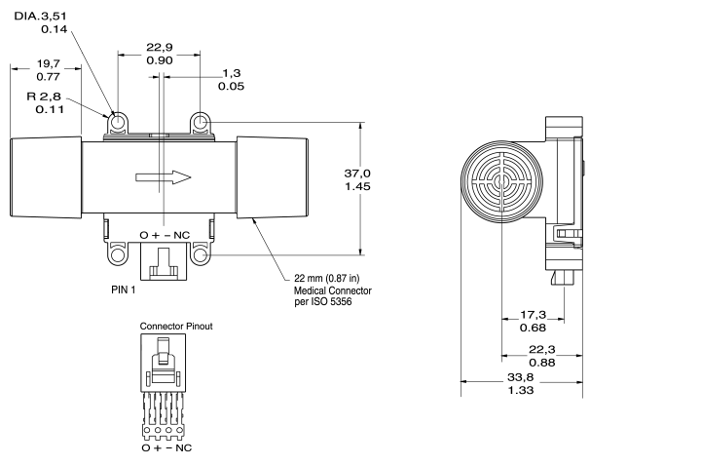
Figure 1-Mass flow device, (Honeywell, AWM720PI), schematic with dimensions
Lastly, due to the decision to use electrical components to construct the VAG, several additional features were able to be added to the device. An additional thermistor (Microchip Technology, MCP9700A ) was added to directly measure the ambient air temperature. The volume of air initially introduced to the patient will change when the air reaches the patients lungs due to Charles law, (V₂=V₁*[T₂/T₁]). The added thermistor is able to help account for the difference in air volumes between the amount initially administered to the patient and the amount that actually reaches the lungs by providing the microcontroller with temperature fluctuations measured as changes in resistances of the circuit. The microcontroller then is able to easily convert the resistance change to a quantifiable temperature and, finally, volume change again based on Charles law. As a result, the LED will display an adjusted, more accurate reading. Additionally, two LED’s were incorporated in order to provide an indication of low battery power to the user. Lastly, an LED metronome was built into the device to provide a timing mechanism to assist the user in determining when to inflate and subsequently deflate the BVM bag. The metronome will potentially increase user awareness in an emergency rescue setting by providing an LED alternating “on-off” signal corresponding to recommended “inflate-deflate” cycles published through the American Heart Association [2].
Upon determination that the method of measuring airflow volume would be accomplished through the use of electrical circuitry, it was decided that a power switch would be incorporated into the design. The switch would be controlled by the user and will permit the device to conserve power while not in use.
Following the determination of the electrical components intended to be used, a schematic of the circuitry was developed (fig. 2). The schematic was constructed in order to provide a blueprint to follow when moving forward in the design process. It was determined from the circuitry blueprints that the overall size of the circuit would be approximately 5cm x 2.5cm x 1.25cm with the mass flow device tubing having a length of 6.25cm.
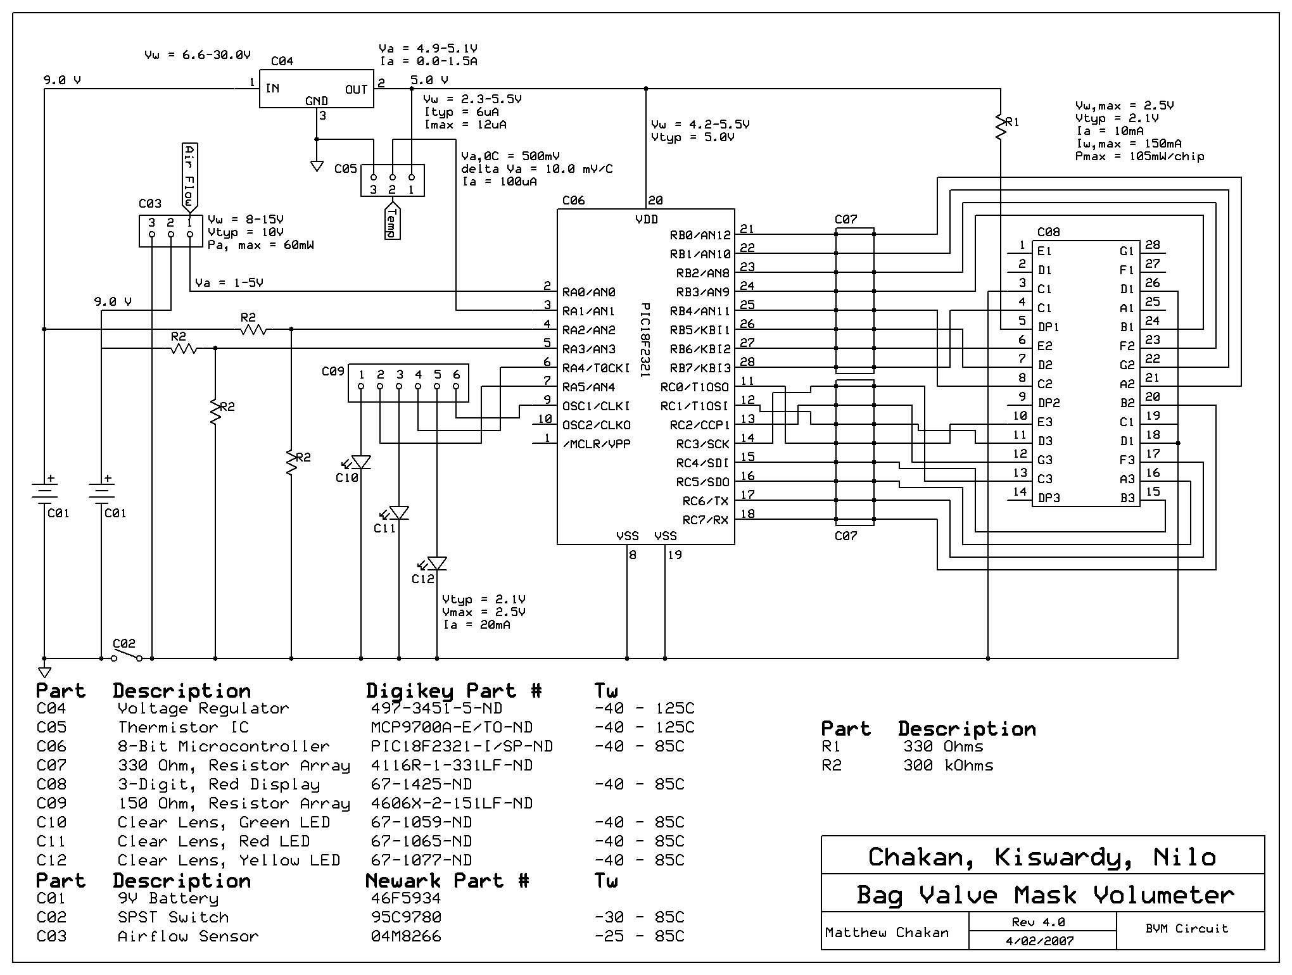
Figure 2-Volumetric airflow gauge circuit schematic
Specific Aim II: Determine an optimal design for the housing of the VAG, taking into account the VAG dimensions and requirements, standard BVM designs, ergonomics, and safety issues.

Once the conceptual design of the electronic circuitry for the gauge was developed the casing to house the components could be designed. Before prototypes were developed a theorized model was designed taking into account several factors including; electronic circuitry dimensions, standard BVM dimensions, ergonomics, and safety issues. First, the casing needed to properly house and protect the electronic circuitry as well as isolate it from the inside of the airflow tubing in order to eliminate the direct path of the electronic components to the patients’ airway. In order to successfully accommodate the electronic circuitry a minimum void of 5cm x 2.5cm x 1.25cm had to be created inside the casing as determined in specific aim I. In addition, the casing had to provide a compartment for the power source to be housed. As determined in specific aim V, the power source would consist of two 9V batteries, therefore the compartment requirements were 5.0cm x 3.6cm x 2.7cm. A removable face plate would be required in order for the user to easily access the battery compartment for periodic battery replacement. Lastly, the casing would require a space for the mass flow tubing which measured 6.25cm long with a 3.7cm diameter. The overall shape of the casing was determined based on the overall weight and the optimal spacing between all the electrical components; circuit, batteries, and mass flow device.

Following the compartment conceptualization to properly hold the electronic components, the external casing design also needed to consider the attachment to standard BVM tubing. It was determined that the optimal placement on a standard BVM system for the VAG device would be on the proximal side (closest to bag) of the one-way flow valve. There were several reasons for the placement of the VAG on the proximal side of the valve. First, it will prevent any expiratory air from the patient from having an effect on the mass flow device. In addition, the one-way flow valve may act as a restriction if components break and enter the tubing. Once the attachment position was determined the VAG casing had to be designed to properly fit standard BVM tubing, preventing any air leaks. Standard tubing diameters (Laerdal) were found to be 23mm on the proximal tubing side and 15mm on the distal tubing side.

Lastly, the housing was designed to incorporate as few individual parts as possible in order to minimize the spaces where water may leak into the device and damage the electric components. The finalized conceptual design incorporated three separate parts; main case, battery face plate, and front cover. The material characteristics of the housing were taken into consideration in specific aim IV.

Specific Aim III: Construct a computer-aided prototype of the VAG including casing.

Once the conceptual design of the VAG was developed, computer-drawn schematics were constructed. The program used to construct the blueprints of the casing was Solidworks and a Windows based Office product was used to construct the electronic blueprints. The conceptual data for the electronic circuitry was used to create the schematic shown in specific aim I. In addition, a more detailed drawing of the circuit board was created in order to determine specific placement of all components on the board (fig. 3). The electronic circuitry design involved the placement of components on either side of a circuit board in order to prevent crossing of lines. This design also minimized the space required by the electronic components.

The housing design was developed using a Solidworks drafting program. The dimensions determined from the earlier conceptual design process were incorporated into the schematics. In addition, the computer-drawn schematics of the housing included space for the electronic components. A volume of approximately 5cm x 2.5cm x 1.25cm was needed for the circuitry. The final design would provide a central portal through which the tubing from the BVM would run. As noted earlier, the proximal BVM tubing is intended to connect to the mass flow device which will sit in the middle of the housing. The exit portal of the VAG is intended to connect to the distal tubing of the BVM, above the one-way flow valve. Lastly, an internal volume of 5.0cm x 3.6cm x 2.7cm was needed to house the two 9V batteries. The final computer-generated design is shown in fig. 4 & 5.

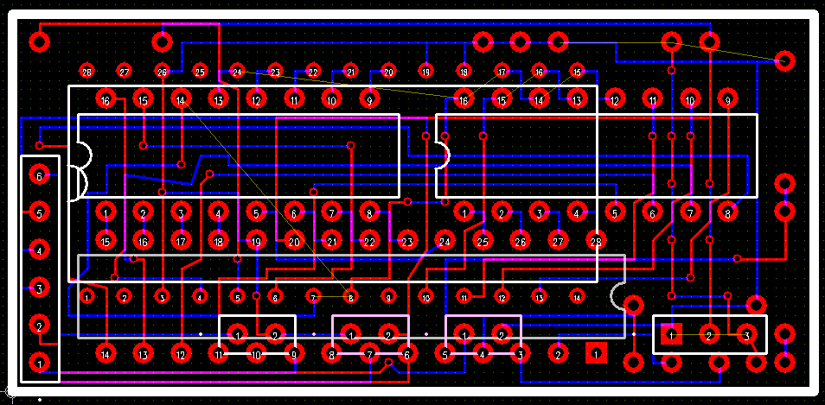
Figure 3- Electronic circuit board schematic for the volumetric airflow gauge

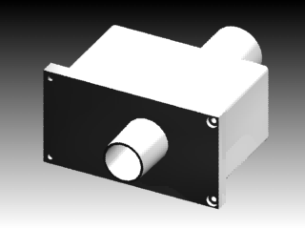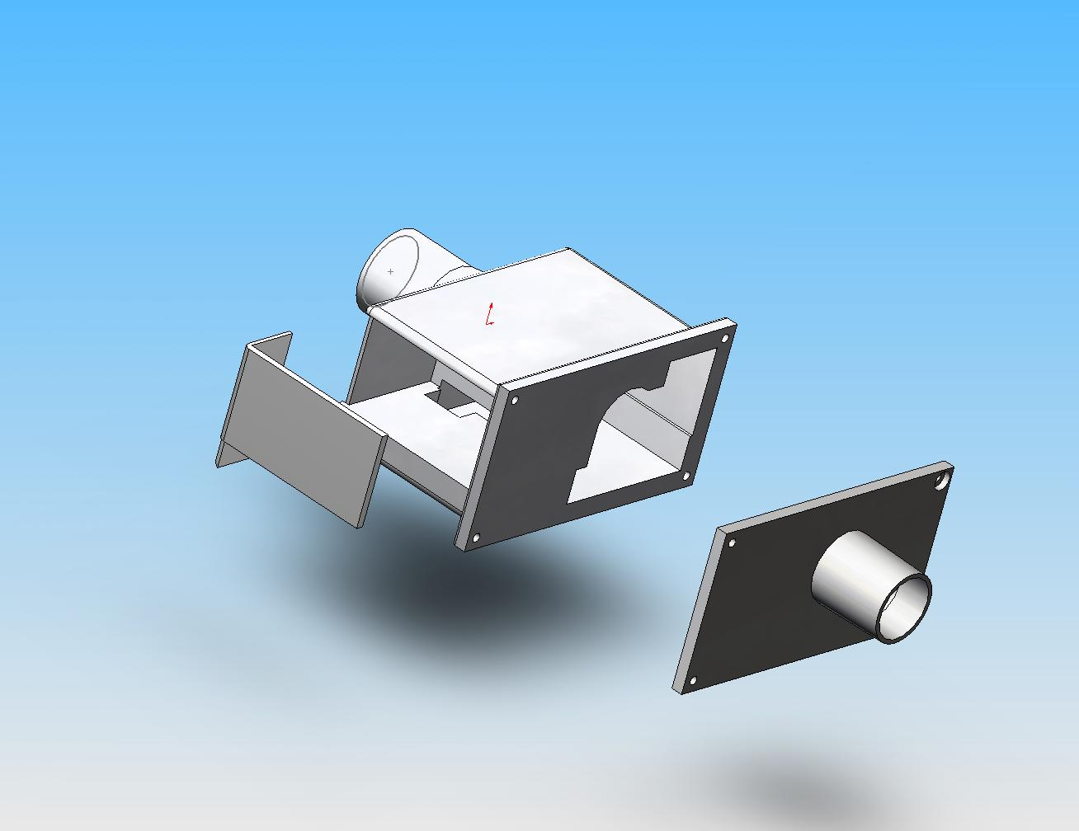
Figures 4 & 5- Computer-generated design of the housing for the VAG. Figure 5 shows the individual components of the design.

The housing design consists of three individual parts; a main compartment, a face plate, and a battery compartment cover. The face plate is intended to provide easy access to the electrical components housed inside the case. From the computer-generated design, it is easy to see that the face plate has the same dimensions as the side of the main compartment. Four guide holes, intended for four #4-40 x 0.25” screws, are noticeable on both the face plate and main compartment. The four screws along with a rubber gasket will provide a tight seal between the two parts as discussed in specific aim IV. A third part was added to provide easy access to the battery compartment. The battery compartment plate incorporates dimensions that allow it to sit flush with the main compartment. Another #4-40 x 0.25” screw will be used to securely hold the plate against the main compartment. The thickness of the overall housing design was not a consideration at this point. Once a working prototype has been developed, the overall design will be streamlined in order to reduce sharp corners and overall size, therefore, minimizing the weight.

The computer-generated design was the first step in creating a visual model of the VAG. Following the design, a working prototype was constructed as detailed in specific aim IV.

Specific Aim IV: Manufacture a working prototype of the VAG based on the computer-generated schematics.

The working prototype was developed in two separate steps; electrical circuitry construction and housing construction. Once the two parts were complete they were combined to create the VAG. The electrical circuitry was constructed utilizing standard soldering techniques. The board was constructed as shown in figure 2. The microcontroller, (Microchip Technology, PIC18F2321), was programmed using common C computer programming methods. The program was designed to measure the airflow volumes recorded from the mass flow device, interpret ambient temperature measurements from the thermistor, and determine power supplied to circuit. The microcontroller calculates the cyclic air volume by taking into account the direct reading from the mass flow device as well as the ambient temperature measurement from the thermistor. The air volume takes into account both of these factors based on Charles law (specific aim I). The final calculated air volume is then relayed from the microcontroller to the LED display. In addition, the microcontroller continuously takes battery voltage measurements in order to determine the power input to the circuit. Two LED’s are incorporated below the display and connected to the microcontroller. When the power input drops below 8V for the battery, or below 6.6V for the microcontroller battery, the microcontroller lights the proper LED, indicating to the user that the battery needs to be replaced. It was determined through the voltage calculations of the individual components, mentioned earlier, that the circuit is inoperable below these respective voltages. Lastly, the microcontroller actively controls the LED metronome feature. The LED is provided periodic voltage from the circuit causing it to light and subsequently dim according to the programming of the microcontroller. In future designs, the C programming of the microcontroller may be changed in order to adjust the timing of the metronome feature. In the prototype it has been set to a “two-on-one-off” display, causing the LED to light for 2s and then subsequently dim for 1s. As mentioned previously, the recommended ventilation technique is ventilation/rest in a 2:1 ratio.

The electronic circuitry was constructed in order to allow the placement of the LED display to be on the external face, providing a maximum viewing surface for the user. The display is not fastened to the circuit along it to be adjusted as needed once seated inside the housing. In addition, the thermistor used to measure the ambient air temperature was designed to sit outside of the external housing in order to obtain a true temperature reading. The thermistor sits <2mm outside the housing, protecting it from any external damage. Finally, as indicated in specific aim III, the batteries are housed opposite the circuitry in relation to the tubing of the mass flow device. Wires were used to connect the power source to the circuit and are situated over the tubing. The housing protects the wires from external damage. The completed circuitry components are shown in figure 6.

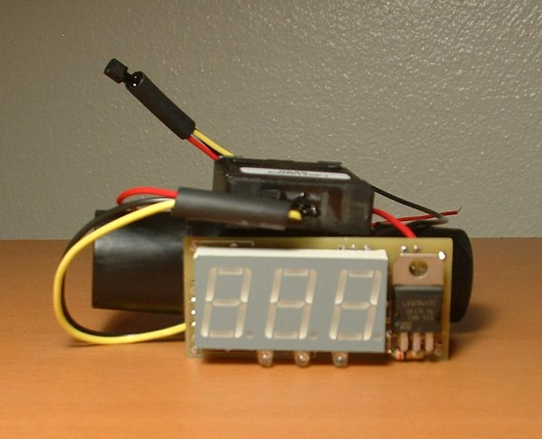
Figure 6- Electronic circuitry prototype. LED 3-digit display shown in foreground, in front of mass flow device tubing (black tubing).

In conjunction with the development of the circuit design, a prototype for the housing was developed. Once the computer-generated housing design was deemed acceptable the prototype was developed using a Stereolithography (SLA) process. SLA is a computer-aided process that creates a solid, resin or plastic 3-dimensional object from CAD drawings. The SLA process utilizes UV-curable photopolymer resin or plastic and a UV laser. The UV laser moves over the liquid resin as guided by the computer drawing, causing the resin underneath to cure/solidify. The casing prototype was able to be developed in several hours using this technique. The final prototype of the housing matched the exact specifications of the computer-generated design and was constructed from a clear poly-ethylene finish.

Following the successful completion of the electrical and casing prototypes, the two were combined to produce the first working model of the VAG. The electrical components were situated inside the housing with the display facing the external side of the main compartment, parallel to the tubing. It will be possible in future models to fasten the electrical components to the housing in order to further minimize internal movement. A small hole was drilled in the plastic housing of the main compartment in order to allow the thermistor access to the external environment. In addition, a small rectangular inlet port, 1.5cm x 0.5cm, was made in the main compartment housing in order to provide the user with access to the power switch. The portal was made on the surface above the battery compartment. The mass flow device was inserted into the housing so that the tubing ends of the device coincided with the portals of the housing. A rubber gasket was placed between the main compartment and the face plate in order to create an airtight seal and the two parts were fastened using four #4-40 x 0.25” screws through the guide holes mentioned earlier (specific aim III). Lastly, two 9V batteries were connected to the circuit and placed inside the battery compartment. The battery face plate was then securely fastened to the main compartment using one #4-40 x 0.25” screw. The overall design of the first working prototype will not be the final reproducible model. The design must be further streamlined in order to produce an optimal design. The final marketable VAG will contain minimal sharp corners and will more closely resemble a cylinder than a box. In addition, the housing will be further minimized in order to reduce the overall weight of the device. The initial prototype was developed shaped as a cube simply to prove that the device would function properly, providing a volumetric display of the airflow introduced to the patients’ airway (fig. 7).
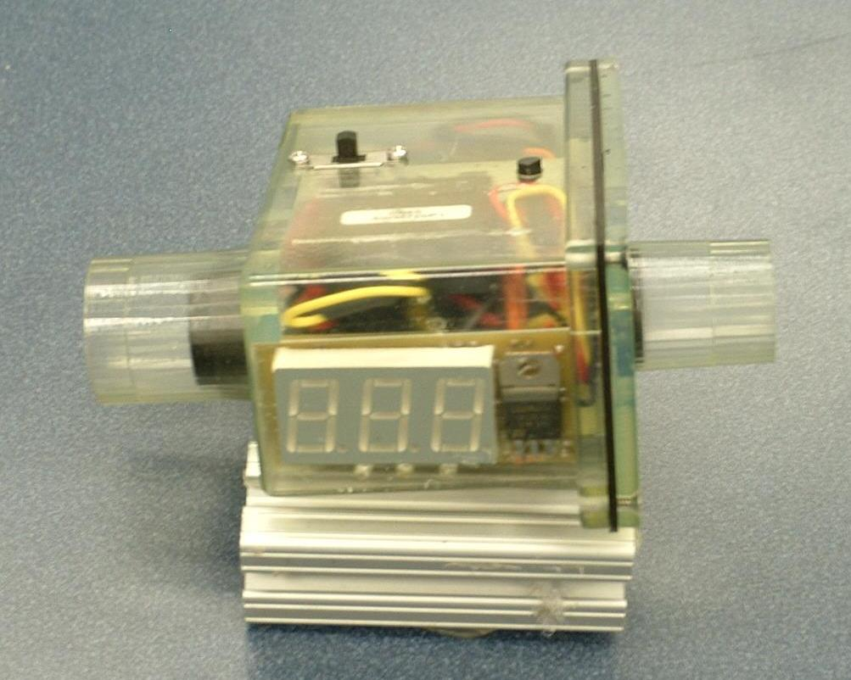
Figure 7- First working prototype of the VAG. The power switch is seen on the upper face of the device (left side). The thermistor sits in the hole on the upper surface (right side) and s used to measure the ambient temperature. The rubber gasket is noticeable (black seal) between the face plate (far right) and the main compartment, creating an airtight seal between the electrical components and the environment.

Following the successful development of the VAG prototype it underwent verification and validation testing as outlined in specific aim V.

Specific Aim V: Submit the prototype to verification and validation testing in order to determine the accuracy, usability, and safety of the device.

Several tests were and will be conducted in order to identify and correct any potential problems with the device as well as provide specifications regarding the VAG. A test designed to determine the optimal power source was one of the first tests conducted, early in the design process. The test was conducted while the electrical circuitry was still easily accessible, prior to its incorporation into the housing prototype. The electrical needs of the circuit were determined by taking into account the specifications of each individual component; mass flow device, microcontroller, and resistors and thermistor and found to be 9V, 5V, and 2.2V respectively. It was initially determined from this data that a 9V supply would provide sufficient power to operate the device. The initial test objective was to determine the average operable life-time of the circuit with the use of a 9V battery. The test was constructed utilizing a vacuum providing a continual flow source to the tubing as well as a voltmeter to determine the power supplied to the circuit (fig. 8). The test was initiated when a new 9V battery was connected to the circuitry and the vacuum was turned on, providing airflow to the tubing. Throughout the test the volumetric reading on the LED display indicated that the device was still functioning properly. The test was concluded when the LED power indicator was activated on the circuit, indicating the power had dropped below 8V (specific aim III). Results of the test indicated an operational circuit-life of 10min. with the use of one 9V battery to supply the power. To date, the test was only conducted once and is intended to be reproduced 20 times in order to verify the findings.

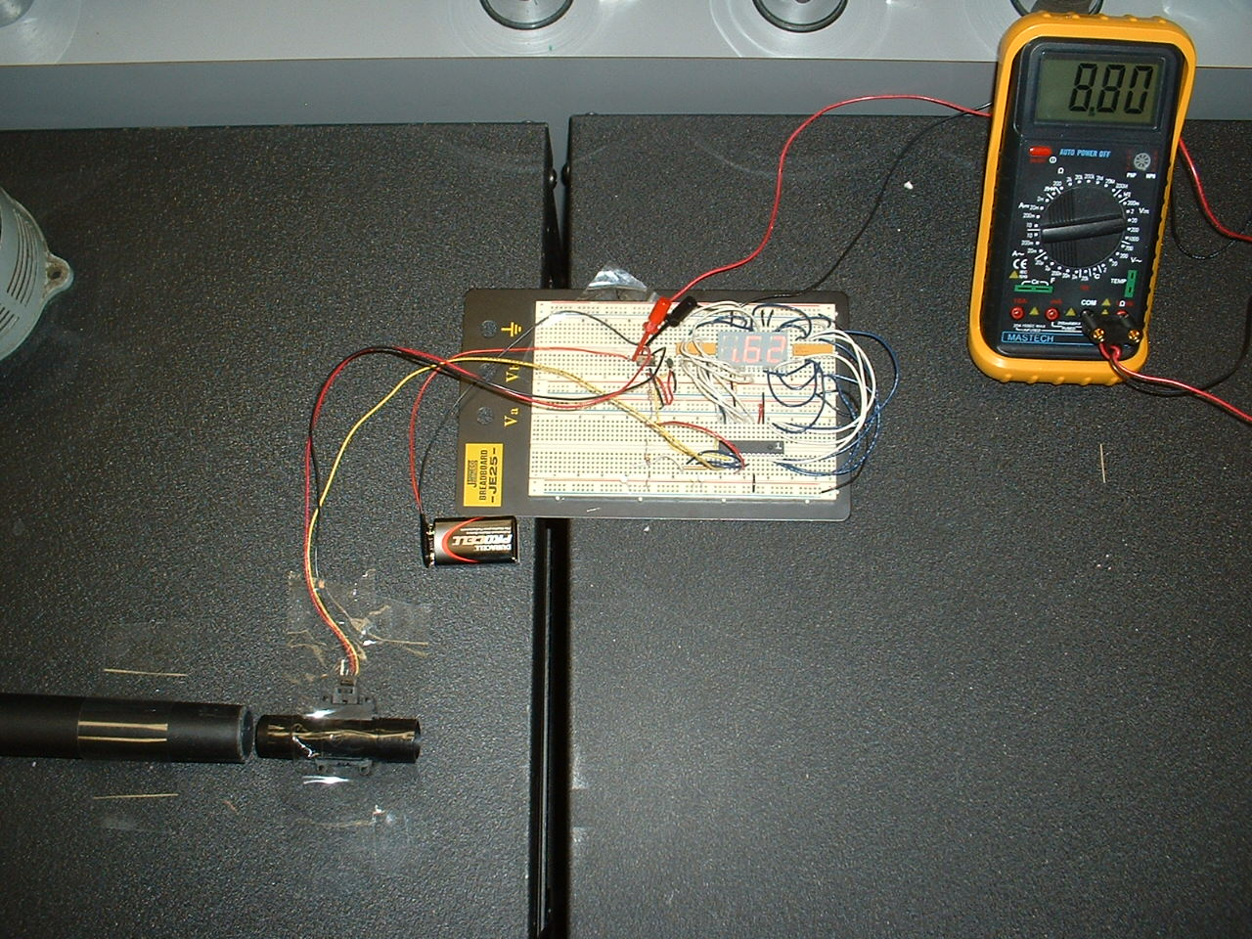
Figure 8- Test designed to determine operational circuit-life with various power sources. Vacuum providing airflow to the tubing shown in lower left. The Voltmeter (upper-right) indicates the power supplied to the circuit.
The results of the first battery test found a very low operational circuit-life, 10min.. A second test was conducted in order to try and maximize the operational circuit-life by providing more power to the components. Two 9V batteries were used simultaneously and the test was conducted in the same manner as the first. Results found that the operational life-time of the circuit using two 9V batteries was 120min., significantly more than with the use of one 9V battery. It was further determined that the advantage of providing an extended circuit-life, from 10min. to 120min., far outweighed the potential disadvantage of increased cost associated with having to purchase two batteries as compared to one. The final design of the VAG is intended to house two 9V batteries and provides an adequate compartment in the main housing (specific aim III).

Future tests will be required in order to determine the accuracy of the device. As a result of previous clinical study data (specific aim I), the desired accuracy range for the device is +/- 50ml. The test design will involve the use of a manikin (Laerdal) with a volume gauge built into the upper airway. It will be assumed that the volume gauge incorporated into the manikin is accurate to within 2% as indicated in the accompanying literature. The VAG will be attached to a manual resuscitator (Laerdal) and the mask of the BVM will be placed over the manikins’ mouth, following standard resuscitation guidelines [2]. The initial test will compare the measured volumetric reading from the manikin gauge to the VAG display. An inflation/deflation cycle will count as one reading and the test is aimed to produce 100 readings, n=100. The data will then be analyzed using z-test analysis in order to determine the significance of the results. In addition, a test will be conducted in order to determine if accuracy is maintained after repetitive use of the device. As stated earlier, the VAG is designed to be reusable up to 6000 cycles (specific aim II), therefore, long-term use data provided to the consumer is critical. The test will be conducted in a similar fashion as the independent cycle accuracy test utilizing the manikin gauge. The VAG, attached to a manual resuscitator (Laerdal), will be subjected to 6000 sequential cycles of airflow. The airflow volumes displayed on the LED will be recorded for all 6000 cycles and compared to the volumes reported from the manikin gauge. Again, t-test analysis will be performed in order to determine the relevancy of the data. It is important to mention that the expected error range should be within 2.00% or +/- 20ml for each 1000ml cycle. The reason for this expectation is due to the literature accompanying the mass flow device indicating an error range of approximately 2.00%.

A final test will determine the stress and strain fracture points of the housing as well as temperature limits. The VAG will initially be subjected to repetitive dropping from 3m in order to determine failure points. In addition, applied point loads and torsional loads of varying force will be subjected to all faces of the housing. From the obtained data, failure points of the VAG will be determined and, if necessary, the VAG housing design will be changed to reinforce the gauge. Lastly, the device will be subjected to various temperatures in order to determine failure points due to extreme environments. The results of these tests will be used as additional product specifications to provide to the consumers.

In addition to the testing mentioned previously, a survey has been administered to various doctors, nurses, and other healthcare providers involved in the treatment or use of manual resuscitation devices. The survey has been administered through the UPMC Center for Emergency Medicine in Pittsburgh, PA. It is intended to provide professionals in the field of emergency medicine an opportunity to test the device and provide feedback on the features and benefits as well as drawbacks to the design. The survey will provide the Design Team with a better understanding of the consumer expectations regarding the VAG. From the results, adjustments may be made to the device.

All data from future tests previously mentioned will be made available upon request. As the verification and validation process continues additional testing may take place not mentioned herein.

F. Conclusion

A prototype of the volumetric airflow gauge has, of this date, been developed. The device combines electrical circuitry components with a lightweight protective housing that will provide the user with a constant display of the airflow volume introduced to a patients’ airway during resuscitation. The device will contain an accuracy range within +/- 50ml air, eliminating the need for the resuscitator to make on-site estimates of introduced airflow volumes. The design will incorporate an LED system, providing the user with both an indication of low power supply and a metronome to gauge inflation/deflation cycles. In addition, the simplistic design of the device allows rapid user comprehension and ease of use. Upon successful completion of the validation testing and statistical analysis, the volumetric airflow gauge will be proven to be a practical device in the emergency medicine field. Most significantly, the device will potentially eliminate the over/under inflation of patients’ airways commonly observed after treatment with a manual resuscitation device. The ability of the user to more accurately provide air to a patient who requires initiation breathing will result in a reduction of side-effects observed in these cases including lung tissue damage, decreased lung compliance, and gastric distension. The co-morbidity associated with these conditions will be reduced, leading to decreased hospital stay and cost incurred by the patient.

With over $1.3 billion spent in 2004 on resuscitation devices, airway management equipment, and ventilators in the US alone, a viable market for the VAG seems extremely plausible. Manual resuscitators, which have not had a significant modification in over 60 years, may soon be revolutionized [3].
G. Citations

1. Davidoff F, DeAngelis CD, Drazen JM, Hoey J, Hojgaard L, Horton R (2006). Emergency Cardiac Care. Prehospital Emergency Care; Vol. 10; 36-48.
2. Kuhns R., Davis J. (2004). A work measurement evaluation of emergency medical services. IIE Annual Conference and Exhibition 2004; 3431-3467.
3. American Heart Association (2005). AHA guidelines for CPR and ECC. Vol. 112; Issue 4; 14-20; 126-131.

4. Von Goedecke A, Wagner-Berger H, Stadlbauer K, Krismer A, Jakubasko C, Bratschke C, Wnzel V, Keller C. (2004). Effects of decreasing peak flow rate on stomach inflation during bag-valve-mask ventilation. Resuscitation; 63: 131–136.
5. International Liaison Committee on Resuscitation. 2005 International Consensus on Cardiopulmonary Resuscitation and Emergency Cardiovascular Care Science With Treatment Recommendations. Circulation. 2005; 112: III-1–III-136.

6. Nolan J. (2001). Prehospital and resuscitative airway care: should the gold standard be reassessed? Current Opinion in Critical Care; 7: 413–421.
7. Wenzel V, Keller C, Ahamed H, Volker D, Lindner K, Brimacombe J (1999). Effects on smaller tidal Volumes during basic life support ventilation in patients with respiratory arrest: good ventilation, less risk? Resuscitation; 43: 25–29.
8. Sheperd C.,(2006). Reflection on a patient's airway management during a ward-based resuscitation. Nursing in Critical Care; Vol. 11, 217-223.

9. Rupenski, Ron (2002). Premarket Notification (5 10(k) - Mercury Medical STATC02TME Tidal CO2 Detector: Summary of Safety and Effectiveness. http://www.fda.gov/cdrh/pdf2/k021576.pdf pg. 2.

