Verification
- Construct testing
  - Intact testing
      - Two intact porcine specimens were characterized by mechanical testing (described below) of the un-instrumented specimens. Flexion/extension and axial rotation range-of-motion (ROM) were determined for each specimen on a serial-linkage robot (a robot-based spine testing system). The ROM and creep behavior of the intact specimens in response to cyclic compressive loads were also characterized on the robot-based testing system.
      - Cyclic axial testing using the spine testing system
    - 150 cycles of 20N were applied quasi-statically in (C) to both constructs
    - The time dependent displacement of the specimen were also measured
2. Robotic load-displacement testing in flexion/extension and axial rotation
i. 2 Nm, adaptive-displacement (with load feedback and thresholding) testing were applied for both motions. Two cycles of preconditioning preceded the recorded ROM path.
ii. The quasi-static load-displacement response of the intact specimen were determined
  - Surgery
    - Following intact testing, a corpectomy was performed on each specimen. A control plate similar to Medtronic’s Atlantis© was used on one spine, and the design (experimental) plate was used on the other. The ability of the plate to appropriately fit the porcine specimen was assessed.
  - Instrumented testing
    - Following the operation, both constructs (the specimen-control plate and the specimen-design plate) were tested in similar manner to intact testing.
      - Cyclic axial testing using the spine testing system
i. 130 cycles of 20N were applied quasi-statically in (C) to both constructs. The change in time-dependent displacement in response to cyclic loading between the two constructs was compared.
ii. The results of intact and instrumented cyclic compression are depicted in Figs 1 and 2. The control plate reduced displacement by approximately 0.5 mm across the 130 cycles. Conversely, the design plate did not reduce displacement in early cycles but reduced displacement by approximately 0.8mm at higher cycle numbers. The creep behavior did not change in the control case while it did change for the design plate.
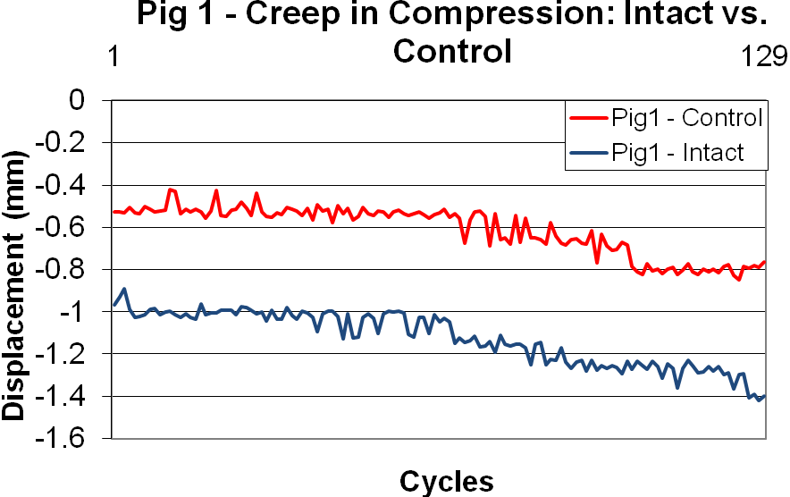
Fig 1. The results for Pig 1 (control plate) in cyclic compression using a 20N load threshold executed on a robot-based spine testing system in a quasi-static manner.
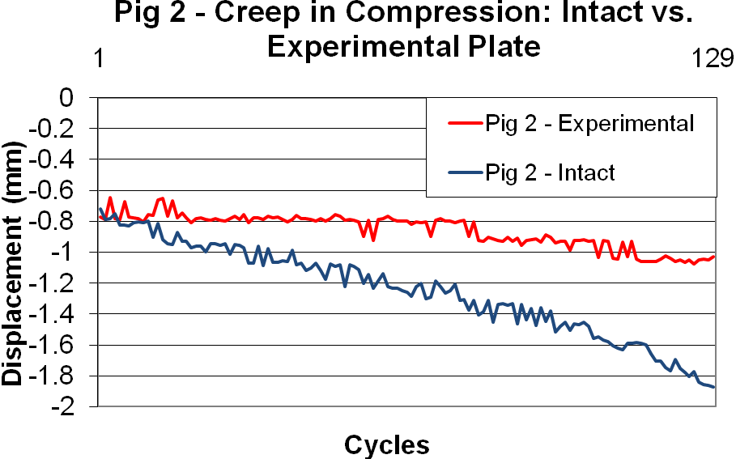
Fig 2. The results for Pig 2 (design plate) in cyclic compression using a 20N load threshold executed on a robot-based spine testing system in a quasi-static manner.

2. Robotic load-displacement testing in flexion/extension and axial rotation.
i. 2 Nm hybrid-control testing was applied for both motions (as in intact testing).
a. Flexion/Extension results: Figs 3 and 4 illustrate the load-displacement results in flexion/extension for both cases. Fig 5 demonstrates the percent reduction of ROM for both plates for both positive and negative moments of flexion/extension.
  - Axial Rotation: Figs 6 and 7 illustrate the load-displacement results in flexion/extension for both cases. Fig 8 demonstrates the percent reduction of ROM for both plates for both positive and negative moments of flexion/extension.

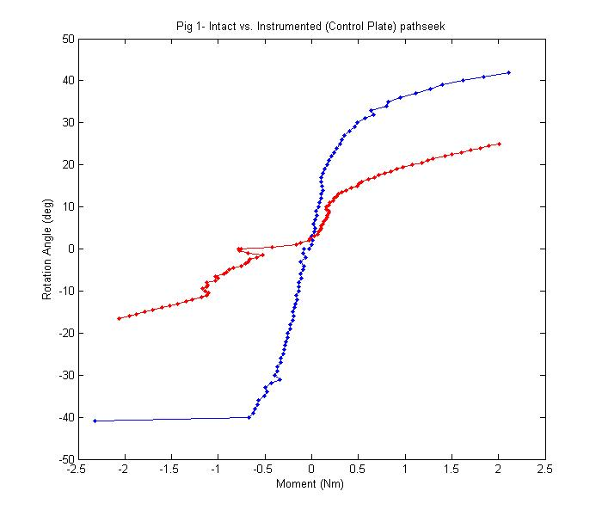
Fig 3. The load-displacement (moment-angle) results in flexion/extension for Pig 1 (control plate) in intact (blue) and instrumented (red) conditions are displayed.
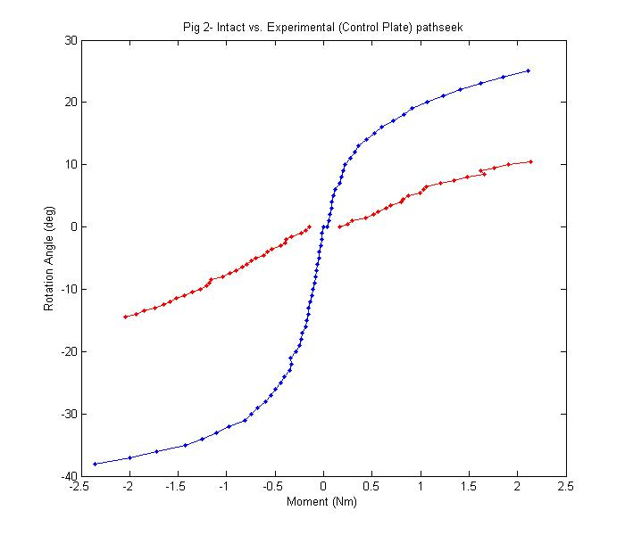
Fig 4. The load-displacement (moment-angle) results in flexion/extension for Pig 2 (design plate) in intact (blue) and instrumented (red) conditions are displayed.
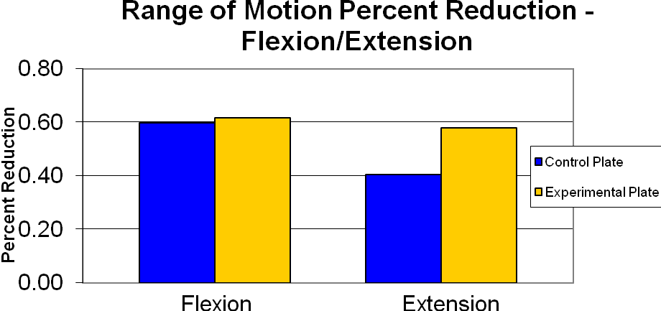
Fig 5. The percent reduction of flexion and extension for each plated specimen are illustrated above.

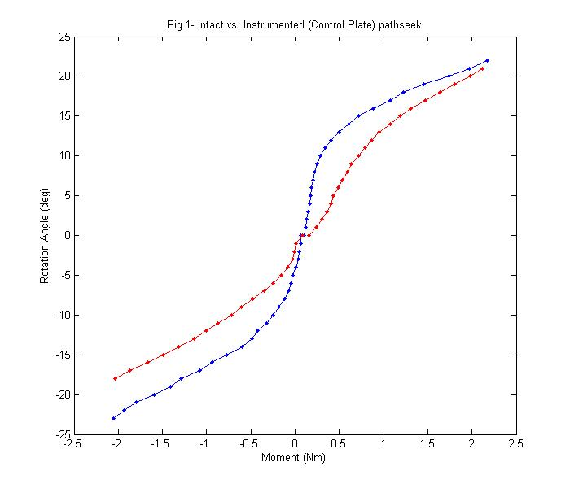
Fig 6. The load-displacement (moment-angle) results in axial rotation for Pig 1 (control plate) in intact (blue) and instrumented (red) conditions are displayed.

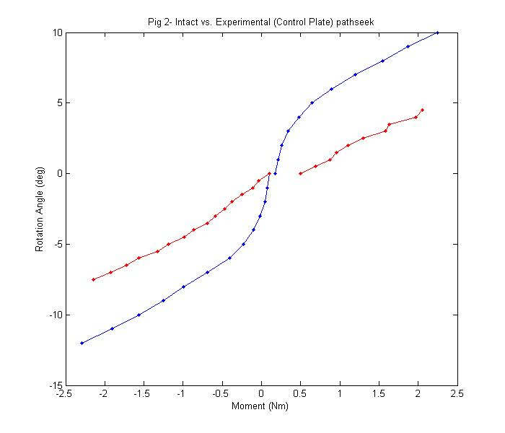
Fig 7. The load-displacement (moment-angle) results in axial rotation for Pig 2 (control plate) in intact (blue) and instrumented (red) conditions are displayed.
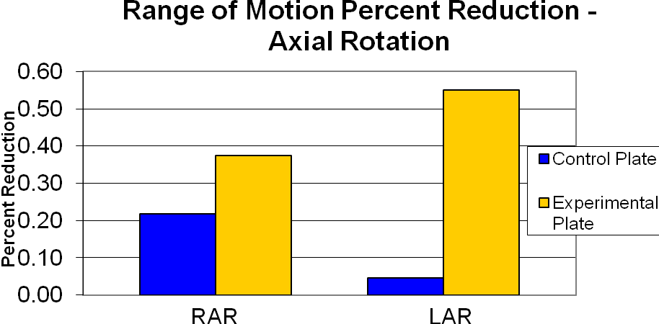
Fig 8. The percent reduction of right (RAR and left (LAR) axial rotation for each plated specimen are illustrated above.

3. Load-to-failure testing was conducted in compression on the ATM
          - Failure in compression was achieved because attaining failure in extension (the most physiologically relevant failure mechanism) is impossible on the spine testing system, due to load restrictions. Compression failure is secondary to extension in regards to pathophysiological relevance.
- Each specimen was mounted in the ATM using proven fixation methods similar to those used in the robot-based spine testing system. Beginning with no applied load, compressive loads will be increased in with a head-displacement rate of 0.5mm/s.
- Both plates broke prior to apparent specimen damage. The metal-coated ceramic plates buckled. The control plate simply buckled; the design plate’s intermediate screws pulled out of the bone prior to fracture. The difference in the failure mechanisms and the load values at failure are illustrated in Fig 9.

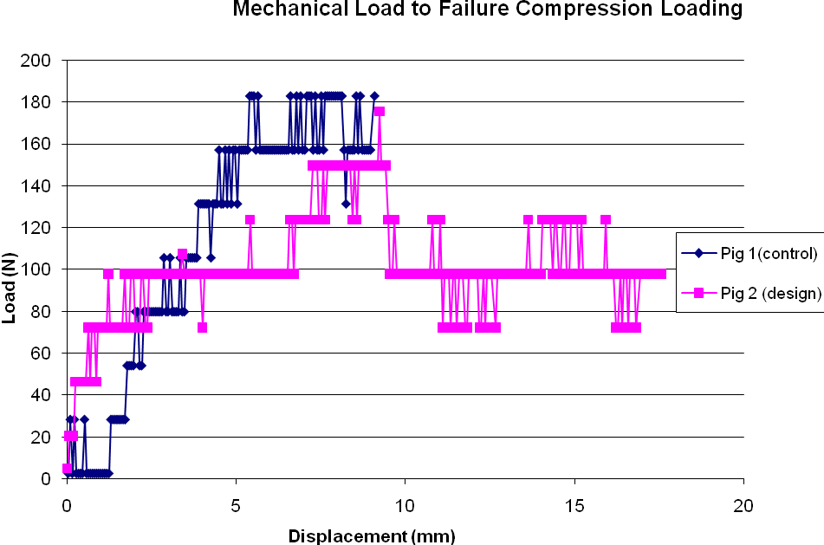
Fig 9. The load-to-failure profiles are shown for the control plate (blue diamonds) and the design plate(pink squares). Failure, in both cases, was the buckling of the metal-coated ceramic plate.
- COSMOS testing (Plate testing)
- Plate testing was simulated in COSMOSWorks (Finite Element Analysis (FEA)). Testing, in part, simulated the material and methods of in-vitro mechanical testing; i.e., the Ni-plated ceramic defined the material (SLArmorTM), and loading values and patterns imitated those from robotic testing. Stress distributions were analyzed. Nevertheless, because model validation could not be achieved with mechanical testing, the utility of the FEA results is in comparison, i.e. looking at difference between the control plate and the design plate under similar loading conditions. Thus for each simulation described, the results are compared between the two plates to glean relevant information.
  - Extension
    - All screw holes were fixed. A distributed force perpendicular to the inferior holes, simulating the clinically observed, “distal-end pullout,” were applied ranging from 0N at the superior end to 70N at the inferior end. The plate deformation and stress distribution were analyzed statically and the factor of safety (FOS) was analyzed under cyclic loading.
      - Static:
        - ≥2Nm (similar to robotic testing) was approximated by applying a distributed 70N force to a plate defined with the material properties of SLArmorTM (see Fig 10).
        - ≥15 Nm, reflecting damaging in-vivo loads, was approximated by applying a distributed 500N force to a plate defined as Ti-6Al4V (see Fig 11).
      - Cyclic:
        - 1000 cycles of 2Nm (SLArmorTM) were applied to the plate to extrapolate information about the plates’ behavior in repeated loading situations (see Fig 12).
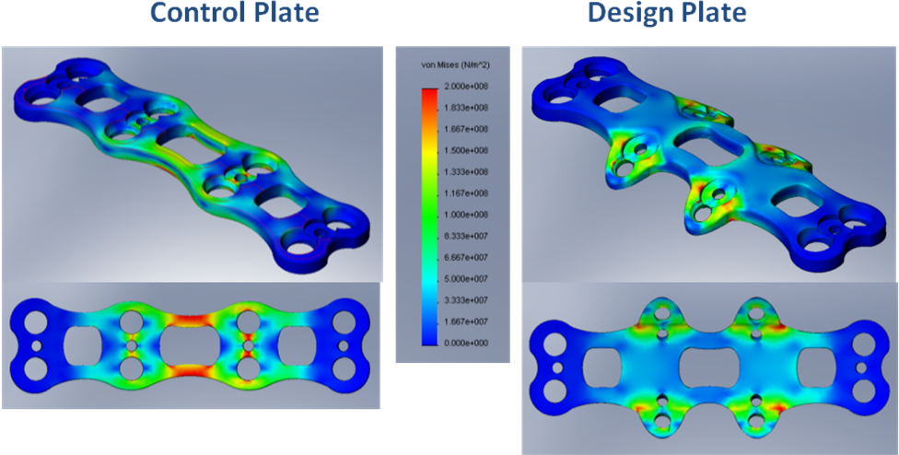
Fig 10. SLArmorTM: Both control and design plates subjected to a 70N distributed load ranging from 0N to 70N normal to the back surface of the plate, simulating the force vertebral bodies exert on anterior plates in extension (2Nm). The von Mises stress scale ranges from 0 Pa to 200 MPa, the yield strength of SLArmorTM.
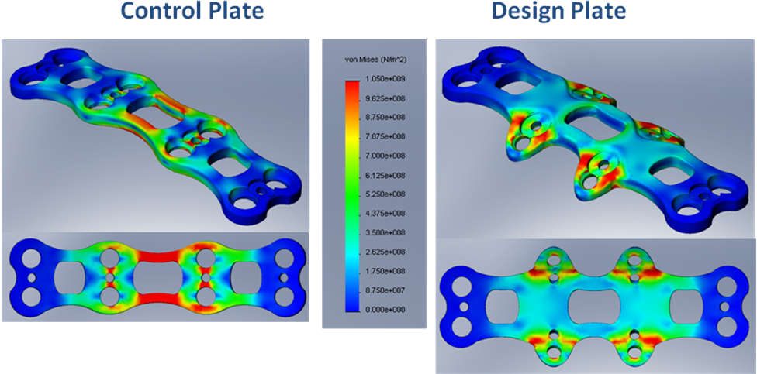
Fig 11. Ti-6Al4V: Both control and design plates subjected to a 500N distributed load ranging from 0N to 500N normal to the back surface of the plate, simulating the force vertebral bodies exert on anterior plates in extension (15Nm). The von Mises stress scale ranges from 0 Pa to 1.05GPa, the yield strength of Ti-6Al4V.
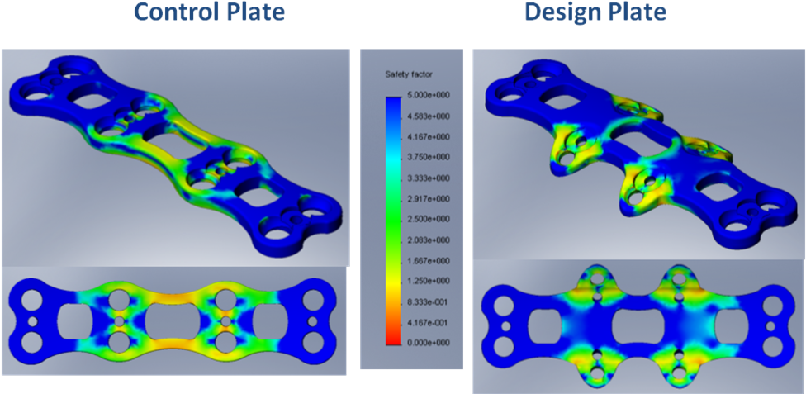
Fig 12. SLArmorTM: Factor of safety (FOS) for 1000 cycles of 70N distributed load on the back side of the plate simulating 2Nm extension. Both the control and design plate results are illustrated. FOS is defined as the ratio between the stress that would exactly cause fatigue failure and the stress Sigma at the considered node.

  - Compression
    - All screw holes were fixed. A force tangent to the curve of the plate, simulating the clinically observed, “subsidence,” was applied. The plate deformation and stress distribution were analyzed statically and the factor of safety (FOS) was analyzed under cyclic loading.
      - Static:
        - 20N was applied. Although plate displacement with respect to the cervical spine can not be simulated simply in FEA (screw-specimen interactions), plate deformations and stresses were analyzed assuming rigid fixation to the spine, reflecting stresses higher than predicted in-situ. Applying 20N of compression to either plate caused negligible stresses to develop.
        - 2500 N, determined to exceed damaging in-vivo loads, was approximated and applied directly to the plate to simulate a “worst case” type of loading (see Fig 13).
      - Cyclic:
        - 1000 cycles of 20N were applied to the plate to parallel robotic compressive testing (see Fig 14).
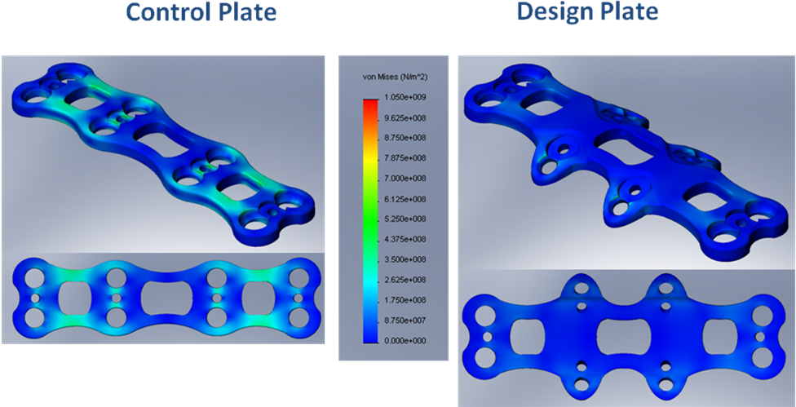
Fig 13. Titanium: Both the control and design plates are subjected to 2.5kN of compression where the loads are distributed evenly at screw locations. The von Mises stress scale ranges from 0 Pa to 1.05GPa, the yield strength of Ti-6Al4V.
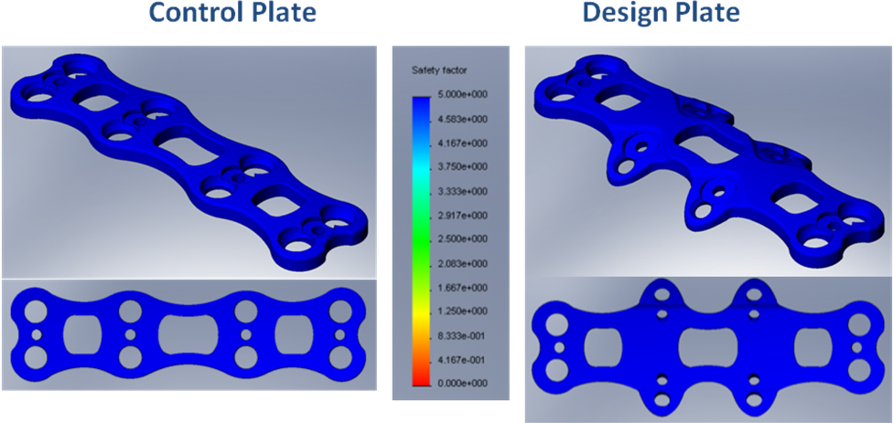
Fig 14. SLArmorTM: Factor of safety (FOS) for 1000 cycles of 20N compression evenly distributed at screw locations. Both the control and design plate results are illustrated. FOS is defined as the ratio between the stress that would exactly cause fatigue failure and the stress Sigma at the considered node.

Validation

- The performing spine surgeon evaluated the plate and scored it with respect to design features and compare it with existing plates. A survey was developed and completed for this task.

Table 1. Surgeon evaluation form following the corpectomy procedures performed on porcine specimens.
Topics | much worse than control plate | Much worse than preferred plate | worse than control plate | Worse than preferred plate | about the same as control plate | About the same as preferred plate | better than control plate | Better than preferred plate | much better than control plate | Much better than preferred plate
Plate
Handling |  |  |  |  | o | o
Shape/size |  |  |  |  | o | o
Overall like/dislike of the plate |  |  |  |  | o | o
Surgery
Time |  |  | o | o
Difficulty level |  |  |  |  | o | o
Feasibility |  |  |  |  | o | o
Acquired stability |  |  |  |  |  |  | o | o
Perceived safety |  |  | o | o
- A spine surgeon simulated a surgery using a porcine cervical spine using existing corpectomy methods and equipment (Medtronic Atlantis) as well as the new plate in conjunction with existing equipment. Following surgery, the stability of the two constructs was compared through a surgeon evaluation (White & Panjabi). This addresses:
  - Perceived safety of the procedure: worse than other plates
  - Perceived stability of the construct: not sure
  - Ability to perform modified procedure: able to do so
  - Compatibility with existing equipment: compatible
  - Time of the procedure (comparison): took longer than normal procedures
  - Perceived stability (t=0), (t>0): not sure
- Despite the lack of convincing enthusiasm on the part of the performing surgeon, the leading cervical spine surgeon at UPMC, Dr. James Kang, expressed interest in advancing this work and trying one of the plates, provided additional mechanical research is done, in actual patients.

