PRODUCT DESIGN SPECIFICATIONS
Retractable Tubing Device for Oxygen Therapy
JMAN: Jamie Haney, Nathan Sendgikoski, Michael Smithula, Andrew Vidokle

DESIGN BRIEF
In considering the current method of in-home oxygen therapy, some disadvantages have been identified in the area of patient freedom of mobility and quality of life. Oxygen therapy is a common medical technique used when patients are incapable of obtaining the levels of oxygen exchange needed to carry out bodily functions such as breathing, metabolism, and movement. Various lung diseases including emphysema and sarcoidosis require the long-term implementation of oxygen therapy. For long affected patients (including admitted hospital patients, assisted living patients, and cancer patients), the limited freedom of movement that results from the oxygen therapy tubing could become discouraging and lead to lack of mobility. With oxygen therapy being one of medicine’s most commonly used procedures, a device that could improve the situation for the patient would be widely accepted by patient and physician alike and easily implemented in any situation where oxygen therapy is used. Our group proposes the design and manufacture of a retractable tubing system to improve mobility and quality of life for patients requiring oxygen therapy.

1.0 Need/function
  - The proposed device would allow for effective oxygen therapy while improving the quality of life by allowing the patient to safely move about their room and reduce the amount of tubing present in their general vicinity.
  - By providing an adjustable tubing length via a retractable oxygen tubing device, the patient will be able to experience more freedom of movement which can reduce the frequency of bed sores, muscular degradation, and psychological disorders.
  - The device would implement a retraction mechanism similar to other retractable devices including extendable electrical cords and pet leashes, but the application to hospital patient care is a unique and marketable idea.

- Performance
The retractable tubing device will function to collect and retract standard oxygen tubing. The retraction will be spring-loaded and initiated by user-controlled push button release of spring tension. The device will be low cost to the consumer, portable, and retraction will be incremental, allowing the user to modify oxygen tubing length based on necessity.

- Specifications
  - Spring. A custom-made constant force spring must be manufactured of pre-stressed strip to provide constant torque no intercoil friction. The spring must have an outer diameter of 1.25” and an inner diameter of 0.5” to fit appropriately within the spring attachment region. The spring must not exceed 0.25” in height.
  - Oxygen therapy tubing. The oxygen therapy tubing must be 50’ long with a ¼” outer diameter. The tubing must satisfy standard tubing regulations including the 3-channel safety design.

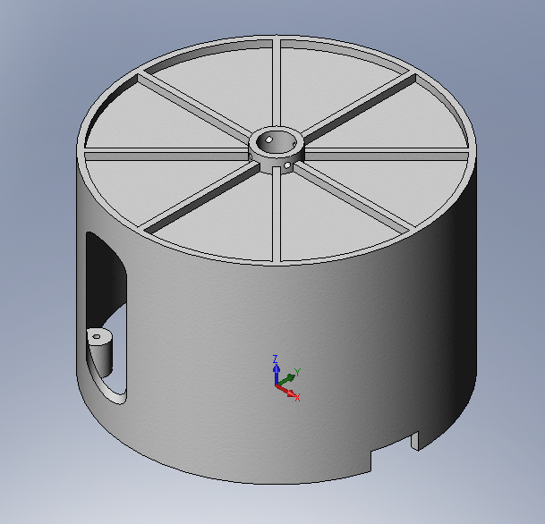
  - Housing chamber. The cylindrical housing chamber must contain the collected tubing before, after, and during retraction. To contain a maximum of 50’ of ¼” outer diameter standard oxygen tubing, the housing chamber must measure 3.5” tall by 5” circumferentially. The housing chamber must contain attachment sites for standard fasteners at 4 locations along the circumference. The housing chamber must also provide two openings for the oxygen tubing path. The 50’ of collection tubing must extend and retract through an opening on the radial wall of the device and the nasal cannula must attach to a swivel tubing adaptor (standard size) at the top of the device.
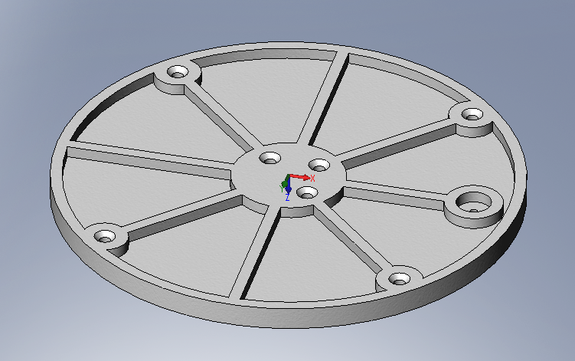
  - Housing chamber cap. The housing chamber cap will have an outer diameter of 5” and a thickness of 0.25”. Four holes must line the outer circumference where standard fasteners must be inserted to connect the housing chamber (2.3) with the cap.

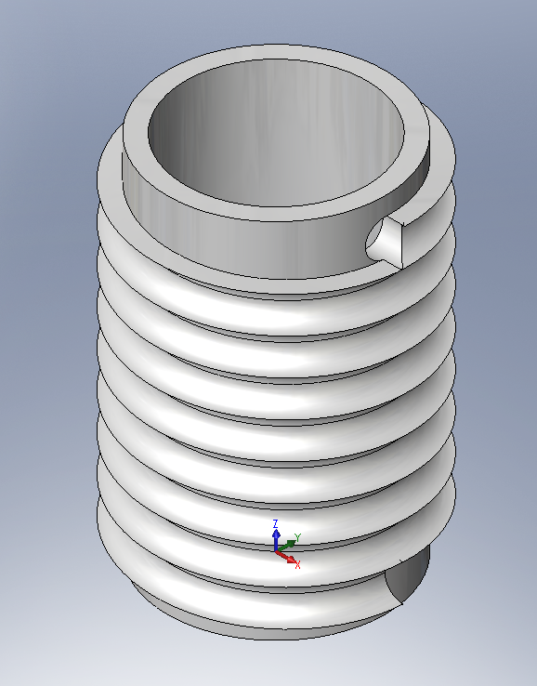
  - Spindle. The spindle must have an outer diameter of 2.95”, inner diameter of 2.7”, and a height of 2.5” to collect the maximum amount of tubing in a coiled conformation. There must be a ¼” diameter hole for the oxygen tubing to enter and ¼” tracks will guide the coiled collection of the oxygen tubing.

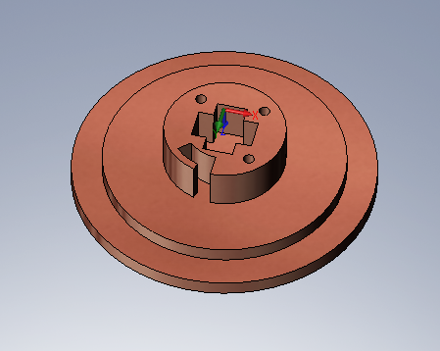
  - Ring. The ring must provide the second spring attachment site as well as the attachment of the spindle to the housing chamber cap. The ring must measure 2.5” outer diameter to appropriately connect with the locking mechanism (2.7).

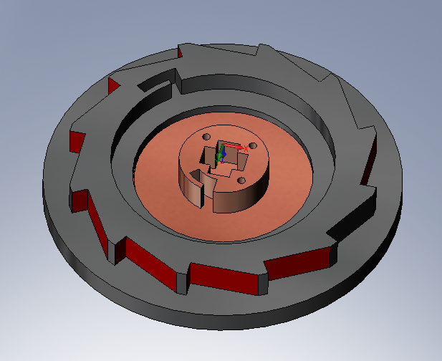
  - Locking mechanism. The locking mechanism must control the retraction by allowing user-control of spring torque. The locking mechanism must allow for incremental retraction via repeating teeth that will catch on a ticker when the lock is in the unreleased position. To release the lock, the user will push on an external button, lifting the ticker from the locking mechanism teeth and freeing the spring to rotate the collection spindle. The locking mechanism must measure an outer diameter of 4”. The lower inside circumference of the locking mechanism will contain a spring attachment site that will match the other spring attachment site on the ring (2.6).

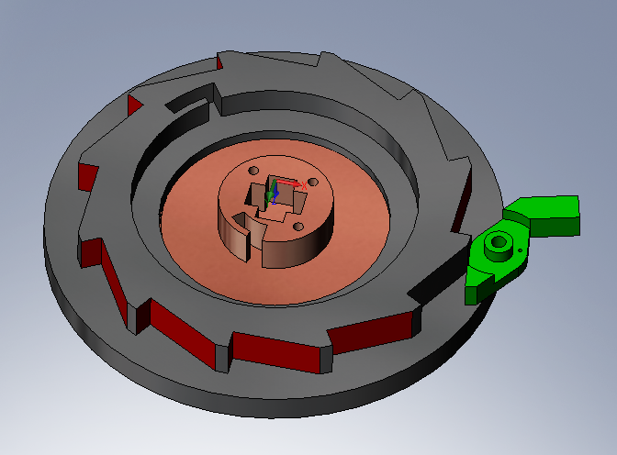
  - Ticker. The ticker must restrain the spring from retracting until it is released by the user. It must attach to the locking mechanism with a standard fastener. A torsional spring will control the quick return (“press-and-hold”) retraction.

  - Belt clip. A belt clip will be present on the back circular face of the device. This must have an attachment and thickness strong enough to sustain its attachment to the user.

- Materials
  - Housing assembly parts. The parts listed from 2.3 through 2.8 must be manufactured through injection molding from high impact, low density acrylonitrile butadiene styrene (ABS).
  - Constant force spring. The constant force spring will be custom manufactured and outsourced from MW Industries, Inc. (IN, USA).
  - Oxygen tubing. Standard oxygen tubing will be outsourced from Salter Labs (CA, USA).
  - Tubing adaptors. All adaptors (flow gauge, swivel top) will be outsourced from Salter Labs (CA, USA).

- Requirements for operation (customer)
  - Attachment/detachment system
    - Sites where the device connects the oxygenator to the patient must be user-friendly and efficient. There must be zero leakage through the oxygen tubing and the assembly must be able to be taken apart and reconstructed with basic tools and fasteners.
    - There must be zero leaking throughout the entire device.
  - User interface (locking mechanism button)
    - A button on the housing unit must function to release the spring tension and initiate retraction.
    - When released, the button must lock the device to maintain the desired length of tubing.
  - Service life
    - The oxygen tube must be replaceable and disposable.
    - The housing unit will not be disposable.
    - The oxygen tubing can be loaded into the housing unit, and taken out when used.
    - The spring must be replaceable, hence not permanently fixed to the device.

- Safety requirements
  - Kinks and overlaps in oxygen tubing must be prevented with high priority – the oxygen tubing must follow a track as dictated by the spindle to avoid this.
  - Pressure must remain constant throughout the system as a drop in pressure will lower flow and reduce oxygen therapy effectiveness.

- Testing
  - Pre-production. Preliminary computational and finite element analysis will be performed on designs.
  - Prototype. A functional prototype must be developed using rapid SLA prototyping. This device will be tested for flow impedance, attachment site integrity, and spring properties. A spring that can retract 50’ of oxygen tubing without damage to the attachment sites will be deemed appropriate.
  - Post-production. Volunteer trials will be conducted to test the functionality and reliability as it relates to the user need.

- Production considerations
  - Target production costs. The product overall unit cost will come from the collection of costs of the above assembly parts. The target cost will lie between $20 and $30 to compare with similar retraction devices.
  - Size and weight. The product overall unit size will measure 3.75” tall and 5” circumferentially. The device must weigh less than 3 lbs.
  - Competition. Current devices with matching objectives in oxygen therapy have been patented and can be found at the links below:
(http://www.freepatentsonline.com/6065490.html, http://www.freepatentsonline.com/7104491.html, http://www.freepatentsonline.com/7104491-0-large.jpg)

- Miscellaneous
  - For preliminary investigations, surveys of oxygen therapy patients will give primary source information such as desired length of extension.
  - Existing devices such as retractable power cords, may give a model to base the mechanism design on.

