Rev: April 20, 2008

SBIR PHASE I

Retractable Tubing Device for Oxygen Therapy

Design Team
Jamie Haney
Nathan Sendgikoski
Michael Smithula
Andrew Vidokle

Mentor
Guy Guimond, MS, NREMT-P, CCEMT-P
Clinical Coordinator
Center for Emergency Medicine of Western Pennsylvania, Inc.

A. Introduction

Oxygen concentrator devices are becoming a more common and accessible treatment in American society. As the population of oxygen therapy users (those affected by pulmonary disorders) is nearing 50 million, the current oxygen delivery systems are being modified and improved to improve comfort and convenience for the user. In accordance, we are currently developing a device that will allow the dispensing and retraction of otherwise fixed oxygen tubing to be more user-controlled. Tubing lengths vary from restrictively short (<10 ft) to excessively long (>75 ft); the inconvenience that comes with replacing tubing every time the user’s desired length changes and potential risks of injury to the user were the driving motivations in our proposal to improve the current method of oxygen therapy tubing control. We propose a device that will retract the oxygen tubing to the patient’s desired length so that their freedom of mobility may increase while also improving the safety of that mobility. Our device will function independently of the oxygen concentrator. The purpose for the device is to promote safety among oxygen therapy users while improving their quality of life.

Our specific aims are:

- Target User Screening. The targeted users will be identified through extensive research. A sample population will be polled via third party questionnaire to establish the need of the retraction device as well as guide the development of user-defined product specifications.

- Device Fabrication. Upon thorough review of potential designs, an optimal prototype will be fabricated following the product design specifications laid out in the Preliminary Research section.

- In Vitro Testing. Structural and flow analysis tests as well as potential risk and human factors considerations will make up a comprehensive analysis of the devices verification and validation.

B. Background and Significance

Oxygen therapy is a common therapeutic technique used in hospital and home care, alike. The incidence of this treatment is so frequent that related technology developments aim to increase patient freedom and quality of life. The purpose of oxygen therapy is to provide supplemental amounts of oxygen to patients who suffer from pulmonary or respiratory impairments. In America, pulmonary disease is the 4th leading cause of death [1] affecting over 40 million adults and children. Recent developments have reduced the size, weight, and noise of oxygen delivery systems while increasing the flow rate, efficiency, and lifetime of the devices. With capabilities for support while stationary, portable, or even on an airplane, the design of current oxygen concentrators has reached a new level of patient comfort. What has been neglected, however, is the restrictive nature of the tubing hose and nasal cannula. Modifying the otherwise fixed-length tubing of the currently marketed oxygen concentrators to allow extension and retractability would provide a comprehensive improvement of user mobility and control.

Oxygen Therapy: A treatment prescribed to patients with temporary or chronic respiratory conditions that provide supplemental oxygen to the lungs. Oxygen delivery devices such as compressed oxygen gas cylinders, liquid oxygen canisters, and oxygen concentrators function by delivering concentrated doses of elemental oxygen for uptake and use in bodily operations, metabolism, energy, mood, stamina, and mental alertness. According to a poll of 100 oxygen therapy users, oxygen concentrators are the most common devices in use (Figure 1). Oxygen concentrators, as their name suggests, concentrate the oxygen in the air by eliminating other gases. No canisters or refills are necessary and current portable oxygenators are approved for land, air, and sea travel. However, while they are advertised as “portable”, currently marketed POC can reach up to 17 lbs and almost 2 feet in size (Table A1 of the Appendix) keeping them from being carried along on a regular basis; the portability only pertains to travel.

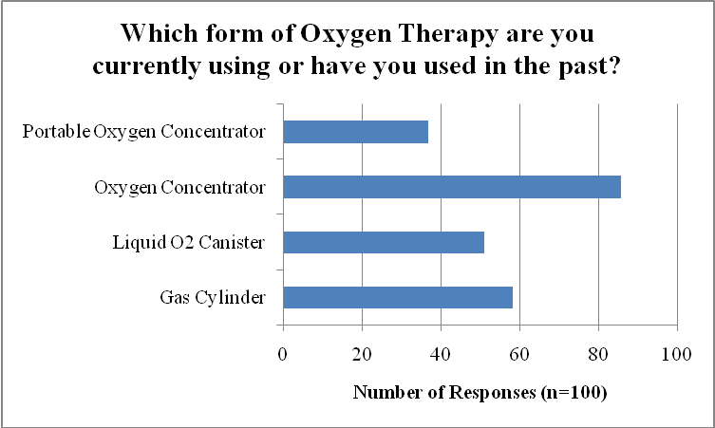
Figure 1. Survey of OxygeNation.org community of oxygen therapy users [2] showing that most common oxygen therapy treatment is oxygen concentrators.

All methods utilize oxygen transport tubing to connect the oxygen delivery device to the user’s intake port (most common are nasal cannulae but more severe disorders require face masks or trans-tracheal connectors).

Targeted Users: The most common precursors to oxygen therapy: emphysema, bronchitis, and sarcoidosis are grouped into a disease class known as chronic obstructory pulmonary disease (COPD). The 16 million Americans that are diagnosed with COPD are prescribed an oxygen therapy plan that could require short-term (<6 months) or long-term treatment that includes daily, hourly, or permanent administration of supplemental oxygen [1]. Eighty percent of the OxygeNation community responded to a poll saying they had been on oxygen therapy for more than a year [2]. Other conditions which use oxygen concentrator devices and transport tubing are the genetic disorders: alpha 1 and cystic fibrosis. Severe cases of asthma and temporary lung infections also require supplemental oxygen.

Current Devices: The transport tubing for all current devices is sold separately from the oxygen concentrator as generic oxygen therapy tubing. Tubing varies by length, weight, diameter, and performance. Table 1 displays the specifications of the standard types of oxygen therapy transport tubing collected from medical supply companies.

Table 1.
Type of Tubing | Length (ft.) | OD (in.) | Material | Cost | Manufacturer
Smooth bore tubing | 4-100 | 1/4 | Medical grade polyurethane | $1-$8 | Salter Labs
Safety channel tubing  | 4-100 | 1/4 | Medical grade polyurethane | $1-$8 | Salter Labs

Alternative Uses for Retractable Tubing: Many medical therapies utilize transport tubing which, as previously explained, have restrictions on freedom and mobility. Specific instances that could benefit from a retractable tubing device include intravenous (IV) delivery therapy and catheterization, both very common in current medical practice.

C. Preliminary Work

Project Begin Date: October 2007
Proposed completion: May 2008

Contributors | Specific Area of Focus
Jamie Haney | Economic analysis, targeted user input
Nathan Sendgikoski | SolidWorks design, design specifications
Michael Smithula | Comprehensive testing and validations
Andrew Vidokle | Fabrication, liaison to outside expertise
Guy Guimond | Mentor, project coordinator

Product design specifications were identified as user-defined preferences to satisfy product need and technical requirements to satisfy project objectives. From the survey conducted among the oxygen therapy users of OxygeNation.org, key preferences were identified to meet the user’s needs. Figure 2 displays the responses to the question, “Which parameters would you prefer for a retractable tubing device?”

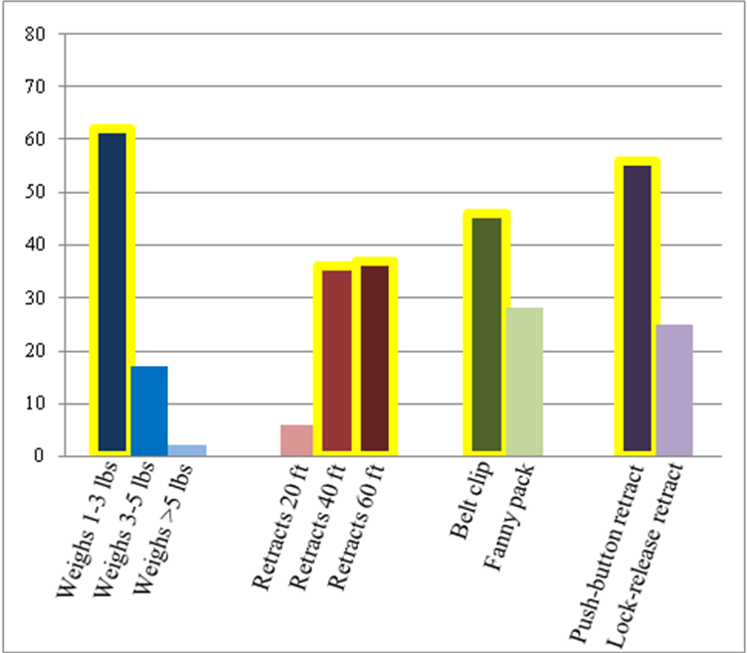
Figure 2. Response data from OxygeNation oxygen therapy user poll. Preferences that were considered in product design specifications are highlighted.

The primary objective behind the preliminary development of the retractable tubing device was to establish an initial design that meets a set of criteria outlined by the project objectives and target user preferences. These function criteria are listed below with their fundamental device components color-coded in Figure 3.

- Organized tubing collection – A spindle component (green) collects and dispenses a maximum of 50’ of standard oxygen tubing in a coiled conformation within a housed cylindrical chamber (light blue). This length was determined from the average of the user-preferred lengths of 40’ and 60’.
- Free rotation of tubing collection – The tubing is collected by spring-loaded rotation of the inner spindle explained above. To avoid kinking of tubing, a rotary union (pink) is included in the design. This piece allows for free rotation of the spindle without negative rotation effects on the tubing.
- Spring loaded retraction – A constant force spring (blue) attaches between the spindle and a spring attachment ring (yellow). Dispensing of the tubing winds the spring (because of its attachment to the spindle) thereby adding to the torsional force. A locking mechanism restricts the release of this force until prompted by the user. When released, the force opposes the direction the spring was wound in (dispensing direction) and the spring retracts to its original conformation, retracting the spindle and oxygen tubing also.
- Locking mechanism – The purpose of the locking mechanism is to allow for incremental retraction and push-button release. Circumferential teeth are designed into the base of the spindle; as the tubing is dispensed, the teeth rotate through a ticker that prevents the immediate retraction (since its direction opposes the torsional force). With this system, the user can determine their desired length of needed tubing and retract when necessary by pressing and holding the button that lifts the ticker releasing the retraction force.
- Airtight tubing attachment – The oxygen tubing attaches at two locations on the device. The cannula tubing (that goes to the user) is stabilized on the airtight rotary union outside of the device. The tubing that goes to the concentrator (50’) attaches to the other end of the airtight rotary union; this is the tubing that is retracted.
- Portability – For the device to be manageable in carrying, toting, or attaching to the user, the measurements and weight must be within a low range. The device prototype weighs less than 3 lbs when developed with SLA materials; it is projected that the commercial device will weigh between 3 and 5 lbs. The device is 3.5” tall and 5” circumferentially. A belt clip is included on the radial face for the user to attach.
- Durability – The materials that are used in the manufacture of this device are low density and high impact plastics. Specifically, (ABS) will be used for the device components because of its high ultimate tensile strength of 40MPa (4 x 10⁷ Pa) [6].

These product design specifications were considered in the development of preliminary designs and an optimal device prototype. Figure 3 displays these designs and the adjustments made that led to the optimal design prototype (Figure 4).

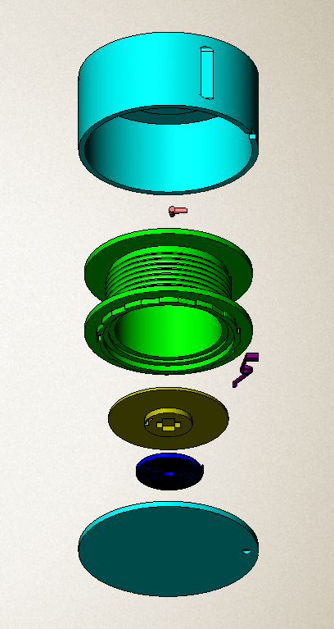
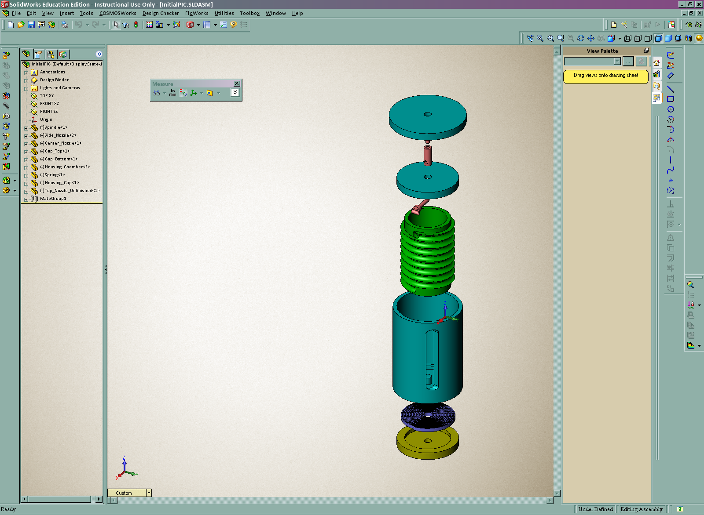
The shape and overall size of the device was reduced with each new design; this will reduce the cost to manufacture as well as increase portability.
Height: 3.5”
Diam: 7.5”
Tubing: 45’
The rotary union, constant force spring, tubing, and fasteners were all outsourced to increase efficiency and reproducibility of the design.
Height: 5.5”
Diam: 3.5”
Tubing: 25’

The spring used in the preliminary designs was borrowed from similar devices; the manufactured product will include a custom manufactured spring specific to the retractable tubing device design.

Figure 3. Initial design(left) and preliminary prototype design (right) with
fundamental components color-coded in each.

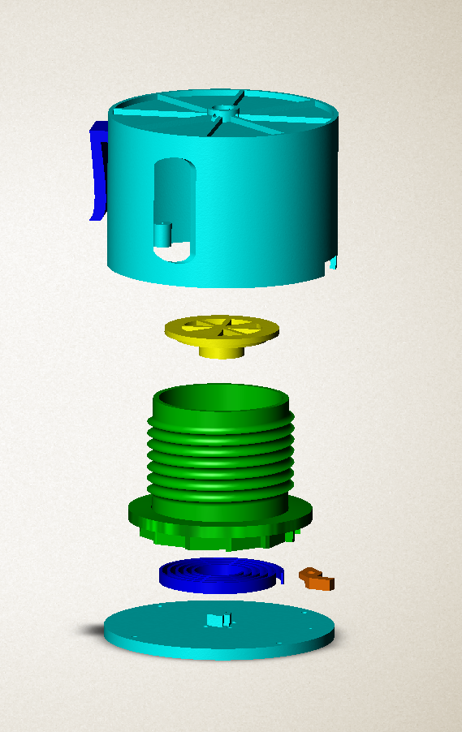
Figure 4. The optimal design revisits the product design specifications listed above while maximizing the function criteria for portability, retraction control, and user-defined preferences.

The prototype of this optimal design was fabricated at the rapid prototyping facilities of the University of Pittsburgh. The prototype was tested for consistency of oxygen delivery, stability of the device encasement, and efficiency of the constant force spring. The data shown below verifies that the device met the technical design criteria laid out above.

Verification and Validation
Prior to prototype fabrication, the simulated design was verified in terms of low oxygen flow impedance and durability of device components. The FEA data displayed in Figures 5 and 6 support this verification. Figure 5 shows the stresses felt on the device after a 1 Nm torque was distributed in the direction of the spring force. While the majority of the device showed a negligible stress (blue), the highest resulting stress was recorded as 6.450 x 10⁴ Pa. This high value is still much less than 4 x 10⁷ Pa, the ultimate tensile strength of ABS.

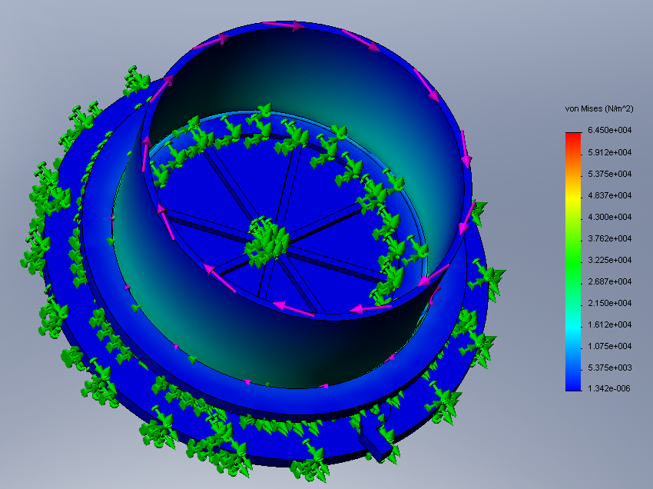
Figure 5. The results of the static analysis test with the restraints(green) and applied torque(purple). The image shows that highest stress is 6.45 x 10⁴(red) and the majority of the device is unaffected(blue).

The results of the drop test (Figure 6) showed higher stresses than the static analysis test, with a maximum value of 7.853 x 10⁷ Pa. While this value exceeds the 4 x 10⁷ Pa standard, it should be noted that there are very few locations where this stress is evident. The majority of the encasement shows blue regions of stress values that are very near zero. From these tests it was verified that the structural integrity of the device would not be compromised by environmental forces.

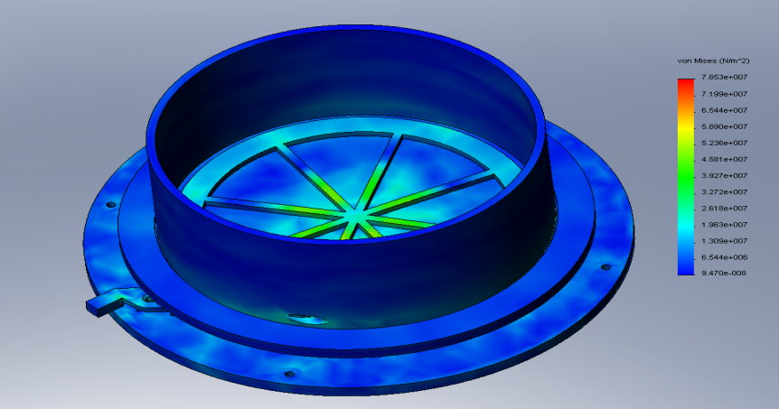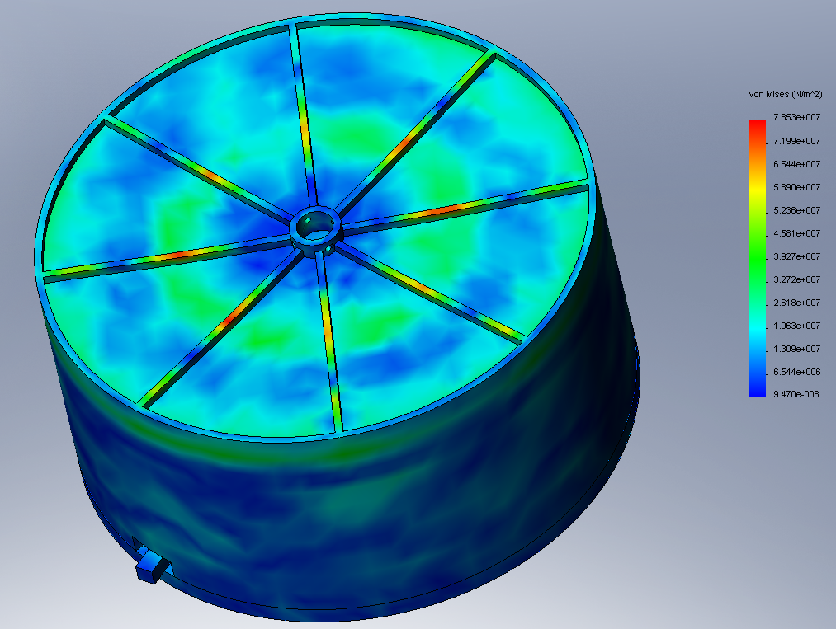
Figure 6. Two views of the drop test results. The left view shows the inside of the housing chamber and the right view shows the results of the entire assembly.

Flow through the tubing in the coiled conformation dictated by the spindle was examined through computational flow dynamics. CFD was used to test the pressure change from the beginning of the tubing to the end of the coiled tubing. The inflow pressure was set to 5.5 psi and the pressure measured at the end of the 45’ of tubing was recorded as 5.456 psi, a drop of 0.044 psi. This drop corresponds to a 0.8125% decrease. Since this drop is less than 5% it is considered negligible and the device will not impede oxygen flow. Note: this test was performed primarily to enhance our knowledge of COSMOS software; results could also be obtained by calculation.

After the product was prototyped, post-fabrication testing was performed to ensure that the device would be safe for users and function effectively. To verify the prototype, a retraction spring consistency test was performed. Tubing was dispensed from the device at varying lengths from 5’ to 15’. The time of retraction to the original position was measured in seconds. Due to an improper prototype spring, only 15’ could be retracted as a maximum instead of the 50’ proposed in the Research Methods. Data was still collected for 5 trials each of 5’, 10’ and 15’ retraction. Figure 7 shows that 15’ could be consistently retracted in less than 3 seconds; the linear relationship between tubing length and retraction time verify that the spring provides consistent retraction.

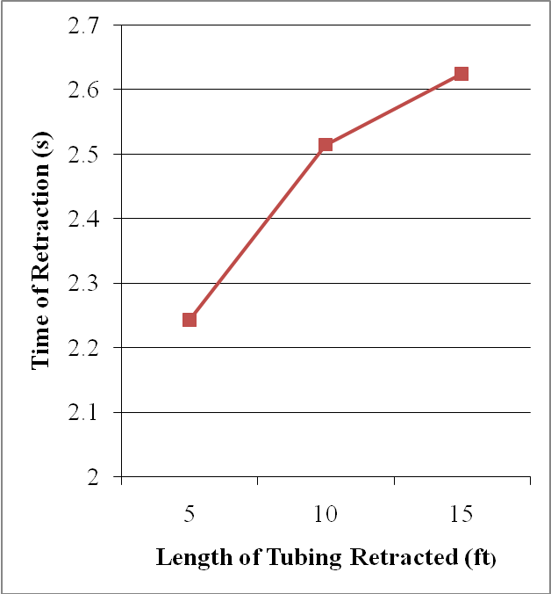
Figure 7. A plot of the length of tubing(feet) against the time it took to retract that length(seconds).

A flow test was performed on the prototype to verify that the results obtained from the CFD carried over to the physical prototype. The flow was measured through 50’ of coiled tubing within the device. A standard oxygen canister with a built-in flow gauge provided inflow rates of 1, 2, 3, 4, and 6 L/min. The values in Table 3 were recorded from an in-line flow gauge at the end of the 50’ of coiled tubing verifying a negligible drop in oxygen flow across the device.

Table 2.
Input Flow (L/min) | Measured Output Flow (L/min) | Percent Loss (%)
1 | 1 | 0
2 | 2 | 0
3 | 3 | 0
4 | 4 | 0
6 | 6 | 0

The prototype’s dimensions for portability, tubing retraction length, retraction control, and overall functionality met the user-defined preferences depicted in Figure 2 and therefore the device was validated to meet the needs of the consumer.

D. Research Methods

Specific Aim 1: Target User Screening
An electronic questionnaire will be distributed to a sample of target volunteers selected from the community of oxygen therapy users. The resulting data will be used to justify the need, verify the design objectives, and modify the user-preferences associated with the design. The questionnaire will be created using an online surveying application, SurveyMonkey.com, and distributed electronically to anonymous volunteers from the OxygeNation.org community of oxygen therapy users. The questionnaire will address the following:
- User’s current methods of oxygen therapy (type of device, length of tubing, time spent on oxygen therapy)
- User’s satisfaction with current methods
- User’s incidence with current method’s problems (Do you find tubing is too short? Too long? Have you ever been injured as a result of improper tubing length?)
- User’s preferences for proposed objectives and features of retraction device

Screen shots of this survey are available in the Appendix.

Specific Aim 2: Device Fabrication
The preliminary prototype will be manufactured to meet the product design specifications using a stereolithography apparatus. The material will be standard prototyping urethane. The device will be fabricated in the University of Pittsburgh Bioengineering Swanson Institute run by Andy Holmes.

The constant force spring will be outsourced to MW Industries, Inc. (IN, USA), a custom-spring manufacturer. The spring will be manufactured of pre-stressed strip to provide constant torque with no intercoil friction. The spring will have an outer diameter of 1.25” and an inner diameter of 0.5” to fit appropriately within the spring attachment ring. The spring will not exceed 0.25” in height.

The oxygen tubing and rotary union component will be outsourced to Salter Labs (CA, USA). The oxygen therapy tubing will be 50’ long with a ¼” outer diameter. The tubing will satisfy standard tubing regulations including the 3-channel safety design.

Specific Aim 3: In Vitro Testing
The safety and human factor related portions of the specific aims require that testing of the retraction device be thoroughly performed. The tests will ensure safety and user-compatibility and will include: computerized testing (Finite Element Analysis and COSMOSFloWorks) and physical testing of a functional prototype.

Pre-Fabrication Testing.
FEA Testing. We will perform simulated strength tests that will analyze potential weak points within the housing chamber of the retractable tubing device. This will involve adding a torque of 1 Nm to the device to mimic the force that will be felt from the spring-loaded forces. The stresses due to the torque will be analyzed. Values exceeding 40 x 10⁷ Pa as an ultimate tensile strength for ABS will deem the design inappropriate for fabrication. All lesser values will be deemed acceptable.

Impact forces to the overall housing chamber will also be tested using the COSMOS drop-test software. A drop will be simulated on the device from a height of 5’ and the effect on the device will be analyzed. Values exceeding 40 x 10⁷ Pa on a majority of the surface will be unacceptable. Areas showing high impact stress will be evaluated individually and modified.

Flow Testing. COSMOSFloWorks 2007 will allow us to verify that oxygen flow through our device is not impeded. Based on commercial oxygen concentrators, we will designate an inflow pressure of 5.5 psi. If the pressure drop over the length of 50’ of tubing is less that 5%, the drop will be deemed negligible and the device will be verified.

Post-Fabrication Testing.
Retraction spring consistency test. The constant force spring needs to be strong enough to retract the tubing back into the housing chamber; coincidently, it must also give enough to allow the user to easily dispense the tubing from the housing chamber. This test will examine consistency of retraction for the prototype. The consistency of retraction will be determined by a linear relationship between length of tubing and time to retract given length. Lengths of 5 to 50’ in 5 foot increments will be retracted in 5 trials each to provide the data for this test.

Flow testing. The purpose of this test will be to determine if oxygen delivery is being compromised at any point in the tubing when it is collected within the housing chamber. We will test the physical prototype in addition to the COSMOSFloWorks analysis explained previously. To perform this test we will fabricate the physical prototype and insert oxygen tubing. We will run a constant flow of air through the system at pressures 1, 2, 3, 4, and 6 psi using a standard oxygen canister. The outflow pressure will be measured with a Salter In-Line Flow Gauge (Salter Labs). If the difference in pressure from the inflow to outflow drops less than 5%, the device will be verified as independent of flow impedance.

With the information that we obtain from performing these tests, we will repeat modification to account for the problems. If one of the tests fails we will go back to design phase and redesign the failing component. Table 2 explains our plan of action upon failure of the above tests.

Table 3.
Test | Plan of Action
(Pre-Fabrication) FEA | Modify material, dimensions, or connectivity
(Pre-Fabrication) Flow Test | Modify spindle or connection site design
(Post-Fabrication) Spring Consistency Test | Modify spring type, torque, or force
(Post-Fabrication) Flow Test | Modify spindle or connection site design

E. References

[1] American Lung Association. www.lungusa.org
[2] OxygeNation Community of Oxygen Therapy Users. www.OxygeNation.org
[3] SurveyMonkey.com online survey creating www.surveymonkey.com
[4] Salter Labs for tubing – various lengths
http://www.directhomemedical.com/oxygen/oxygenmasksandtubing.html
[5] MW Industries Inc. for constant force spring – custom-manufactured
http://www.mwindustriesinc.com/home.html
[6] www.matweb.com for material properties of ABS

Appendix

Table A1.
Oxygen Concentrator | Avg. Size (in.) |  |  | Avg. Weight (lbs.) | Oxygen Delivery (L/min.)
Oxygen Concentrator | Length | Width | Height | Avg. Weight (lbs.) | Oxygen Delivery (L/min.)
SeQual Eclipse | 19.3 | 12.3 | 7.1 | 13.9-17.4 | 1.0-6.0
Respironics EverGo | 12.0 | 6.0 | 8.5 | 8.5-10.0 | 0.5-3.0
Inogen One | 11.6 | 6.0 | 12.4 | 8.3-9.8 | 1.0-5.0

Target User Screening Questionnaire:
Page 1
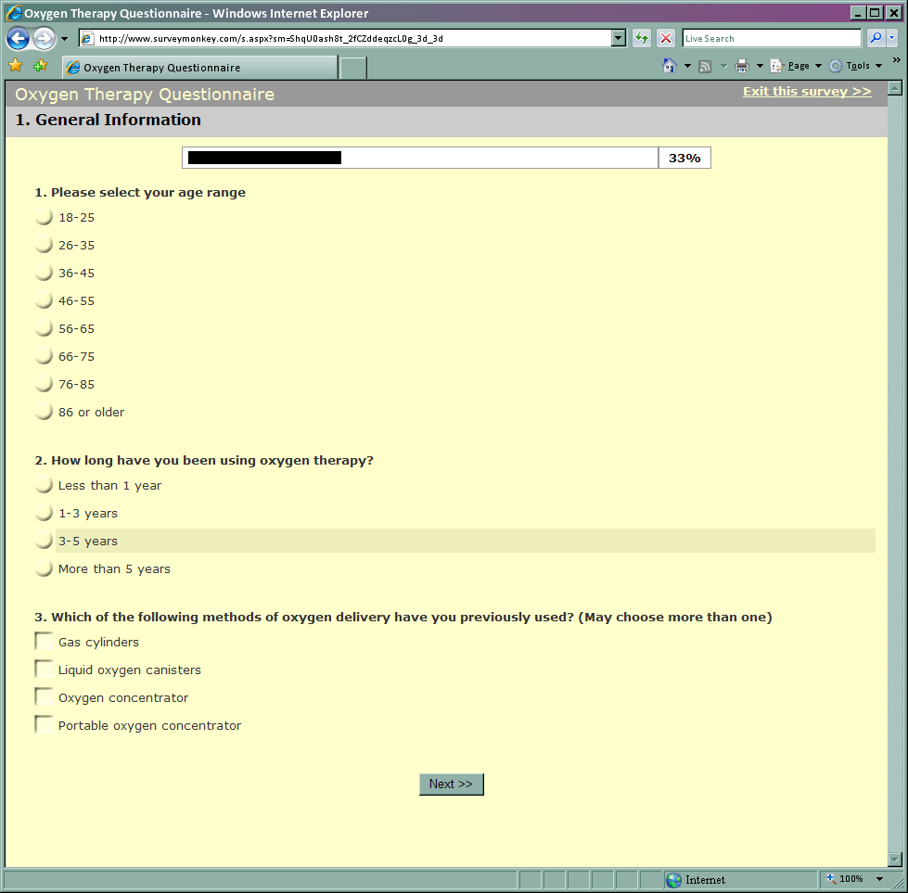

Page 2.


Page 3.


