Kuhn differentiates between two kinds of change over the course of scientific development:
Normal change occurs during periods of normal science—these changes often appear cumulative.
Ex: The discovery of Boyle’s law did not require any new concepts
Revolutionary changes involve discoveries that cannot be accommodated by the concepts in use before they were made
Kuhn identifies three characteristics of revolutionary change:
- Changes are holistic
  - Ex: Individual claims in Aristotle’s physics (such as the claim that a void is impossible) cannot be ‘corrected’ such that the rest of his views remain intact.
- Changes involve a shift in terminology
  - Change in the set of objects or situations to which terms attach
    - Ex: The term cell meant something different to Volta than it does now
- Changes involve a shift in model, metaphor, or analogy
  - Ex: In Aristotle’s physics, the motion of falling stones was the same kind of motion as that of a growing tree—in mechanics these are two entirely different kinds of changes.
  - Planck’s resonators were taken to be similar to Boltzmann’s molecules until it was shown that resonators change energy discontinuously—then
The shift from contact to chemical theory:
According to Volta’s contact theory cells consist of two pieces of metal in contact. In a battery, cells are connected to each other by liquid.
According to the modern chemical theory, cells consist of the liquid and its two interfaces with different metals.
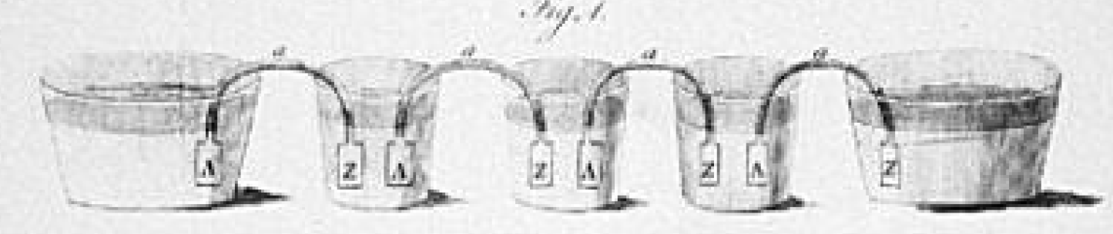
Volta’s Cell: Modern Cell:

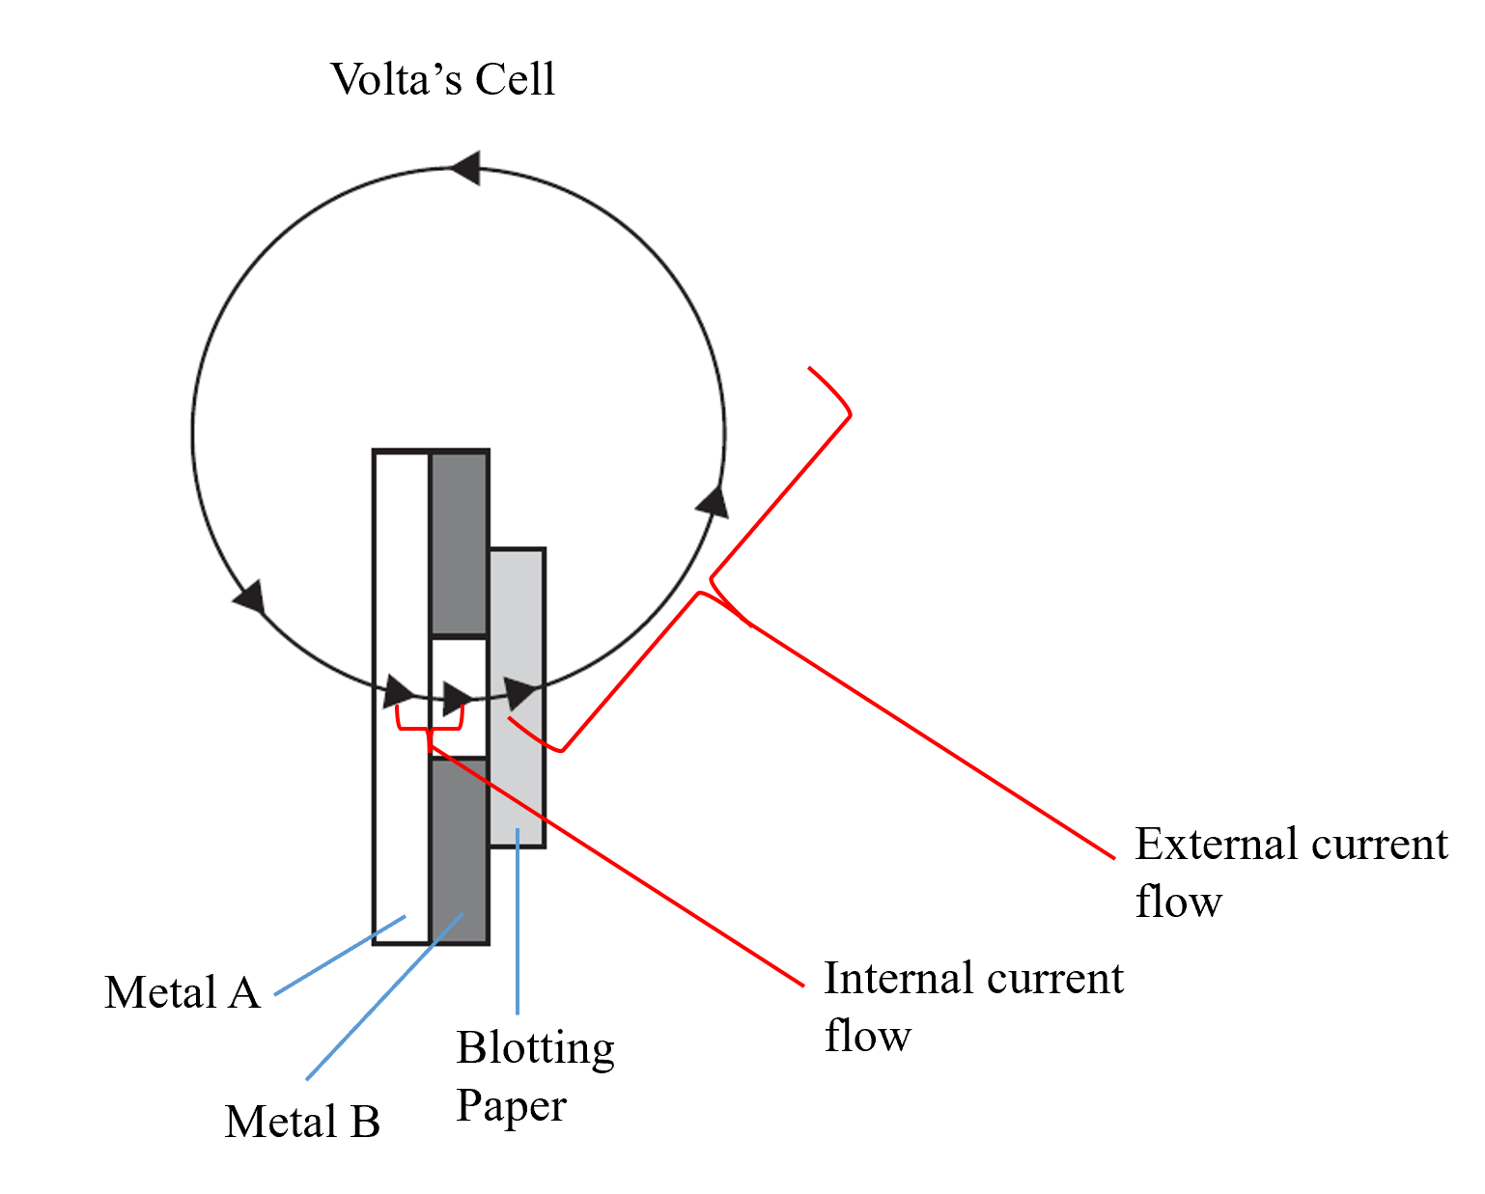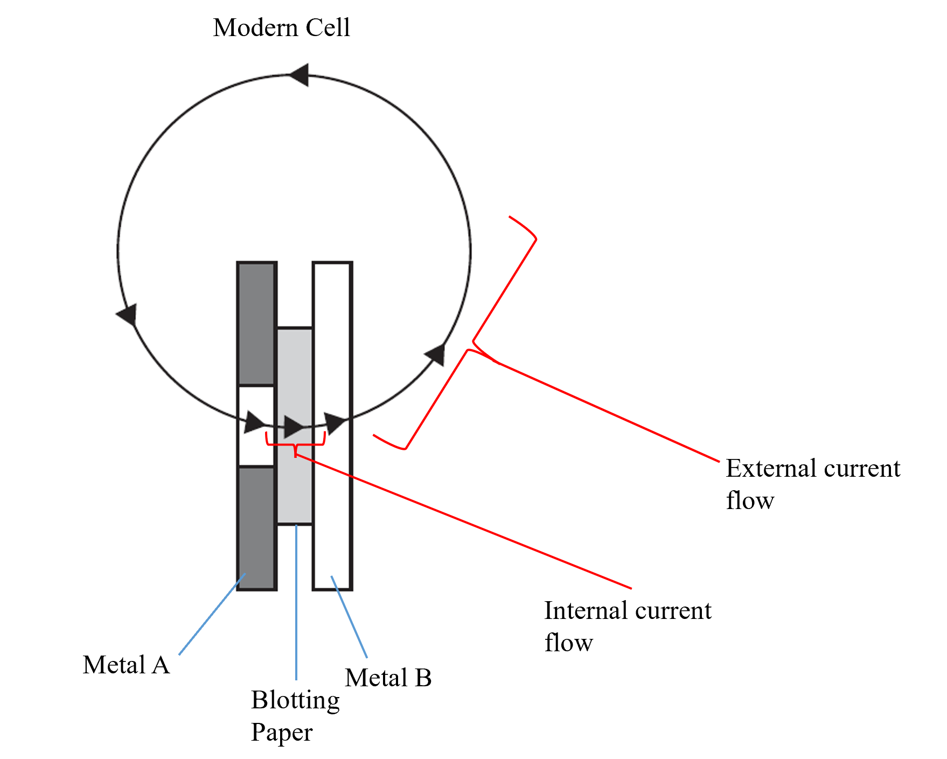
What changed from the contact to chemical theory:
- What a cell consists of (interface of two metals vs two metals separated by liquid)
- Internal current flow becomes external current flow
- Polarity is reversed
- Conceptual role of the external circuit
- The concept of electrical resistance
DQ: Is the shift from contact theory to the chemical theory of batteries a revolutionary change or a normal change? (Or maybe something in between?)
- Does the shift in theories represent a holistic change? Or should we think of it as a case where components of the old theory were altered?
  - Kuhn says yes because the above changes cannot be made in isolation
- Certainly some terms change meaning with the theory shift (e.g.: cells and electrical resistance). But others remain the same (e.g.: internal/external current flow and polarity). Is the fact that some terms change meaning sufficient for Kuhn’s second characteristic?
- Has there been a shift in model, metaphor, or analogy?
  - Kuhn says yes because before change battery cells were like Leyden jars and resistance was like electrostatic leakage and afterwards they were not
Gems:
I thought it was effective for Kuhn to discuss a few examples in depth rather than listing many examples without explaining them thoroughly
Kuhn’s presentation of technical examples is fairly clear, and he highlights the philosophical upshot
Discussion questions:
Are normal and revolutionary change discrete categories? Or does revolutionary change come in degrees?
Is it problematic for Kuhn’s broader view if normal and revolutionary change are not discrete categories?
Kuhn’s main claim in this paper is that revolutionary changes in science share certain characteristics. Is this a philosophical thesis? A historical thesis? An integrated HPS thesis?

