Connecting Philosophy with Actual Science
Philosophy: Interventionist Theory of Causation
Actual Science: Statistical Causal Inference

Directed Acyclic Graph (DAG): a bunch of variables connected by arrows
- Directed: temporal direction embedded in arrows
- Acyclic: no closed loops
- Graph: represents causal structure

Smoking

Lung Cancer
Yellow Fingers

Completeness of DAGs | Incompleteness of DAGs
- All common causes are present  - All arrows are drawn | - Not all mediators are present  - Not all causes are present

Scheines (1997, p.186): “Prior to any interpretation, a DAG is a completely abstract mathematical object.”

Causal Interpretation of DAGs
- What does “Smoking -> Yellow Fingers” mean?
- Manipulating/intervening on smoking changes whether yellow fingers
- If smoke, then yellow fingers
- If no smoke, then no yellow fingers

These are all very good…but how do we get to DAGs and causal inference from statistics and probabilities?

Conditional Independence
- “X ⫫ Y | Z” means “X and Y are probabilistically independent, conditional on Z”
P(X n Y|Z) = P(X|Z) * P(Y|Z)

Unconditional/Marginal Independence
- “X ⫫ Y” means “X and Y are probabilistically independent”
P(X|Y) = P(X) * P(Y)

Causal Markov Condition (CMC): X is independent of all variables (except X’s effects), conditional on X’s direct causes.

- Yellow Fingers and Lung Cancer are independent, conditional on Smoking.

- CMC can be understood as a sufficient condition for causation (Hausman and Woodward, 1999, p.523): If X and Y are dependent, conditional on X’s direct causes, then Y is an effect of X—i.e., X causes Y.

Why CMC
- Causal inference in controlled experiments assumes CMC
- CMC is compatible with philosophical theories of probabilistic causation
- Influential methods in social science, Structural Equation Modelling (SEM) assumes CMC

Faithfulness: Ignore cases where X causes Y, but X and Y are independent, conditional on X’s direct causes.
Smoking

Exercise
Health

- Smoking causes poor Health, but they can be independent, conditional on Smoking’s direct causes.

- Faithfulness can be understood as a necessary condition for causation (Hausman and Woodward, 1999, p.523): If X causes Y, then X and Y are dependent, conditional on X’s direct causes.

Why Faithfulness
- Embraced by working scientists
- No Miracles: Independencies are explained by causal structure rather than chance

Causal Sufficiency: All common causes of the variables were measured.

From Independencies to Causal Inference

CMC, Faithfulness, and Causal Sufficiency all serve to narrow down the set of DAGs that are compatible with the observed data (independencies).

Independencies:
X₁ ⫫ X₂

DAGs:
Assuming CMC
X2
X1

? ? ? ? ? ? ? ?
X3

“Even if we assume that all the Causally Markov graphs that might have produced data with these independencies involve only X₁, X₂, and X₃, then there are still nine such graphs. Their only shared feature is that each has some direct connection between X₁ and X₃ and between X₂ and X₃” (Scheines, 1997, p.194).

- How does CMC—which talks about conditional independencies—give us DAGs based on unconditional independencies?

- What are the other 8 DAGs?

Assuming CMC and Faithfulness
X3
X1
X2

- How does Faithfulness eliminate the 8 DAGs?

Assuming Causal Sufficiency
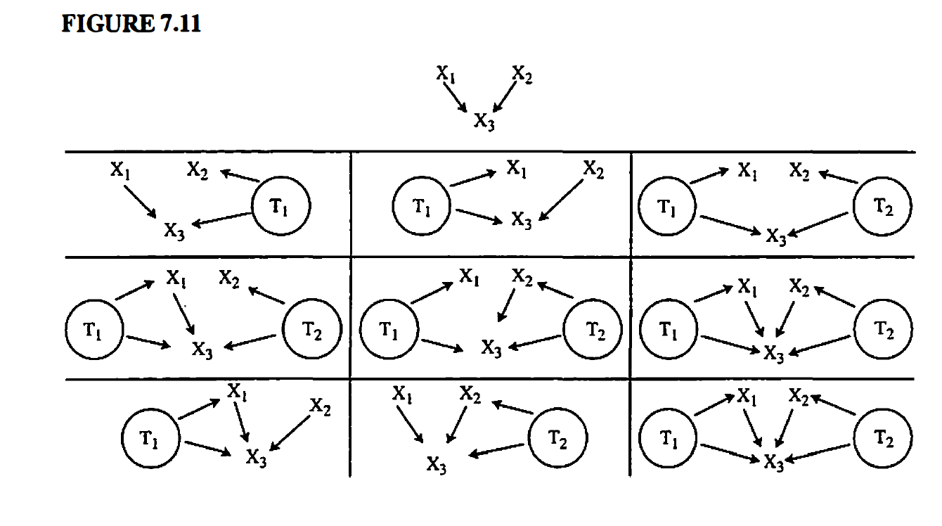
- The above already implicitly assumes Causal Sufficiency: “involve only X₁, X₂, and X₃”.
- Without Causal Sufficiency, there are many possible (infinite?) DAGs.
Gems and Coals
Aspires to be as clear and simple as possible. The goal is explanation.

Assumes a fair bit of background knowledge of the reader. As a result, the paper skips explanations here and there.

Introduces d-separation but refuses to explain it fully…

References

Hausman, D. M., & Woodward, J. (1999). Independence, Invariance and the Causal Markov Condition. The British Journal for the Philosophy of Science, 50(4), 521–583. http://www.jstor.org/stable/40072257

Scheines, R. (1997). "An Introduction to Causal Inference," in V. R. McKim and S. P. Turner, eds., Causality in Crisis? University of Notre Dame Press.

