Panther Grappling Club

Grappling is a martial art like wrestling, judo, Brazilian jiu-jitsu, sambo and others. Matches involve takedowns and end when one partner submits or taps out. Strikes are optional but atypical. Lots of fun and very safe if certain rules are followed.

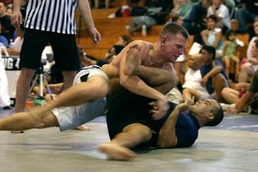
Webpage: http://www.pitt.edu/~jfcst24/grappling.html
Web forum:
http://s15.invisionfree.com/grappling
Contact:
jimmy.cerra@gmail.com

Next Practice: Monday, August 28 7pm-9pm in Trees Multi-Purpose room
------------------------------------------------------------------------------------------------------------
Pittsburgh Kajukenbo Club

We are a group of hard-working martial artists with a variety of martial arts backgrounds and levels of experience practicing the a Hawaiian form of self-defense derived from Karate, Judo/Jiu-Jitsu, Kenpo, and Chinese Boxing. Kajukenbo is a primarily striking art that is centered around practical self-defense "tricks," takedowns, and punishing your attacker(s), as well as some weapons training.

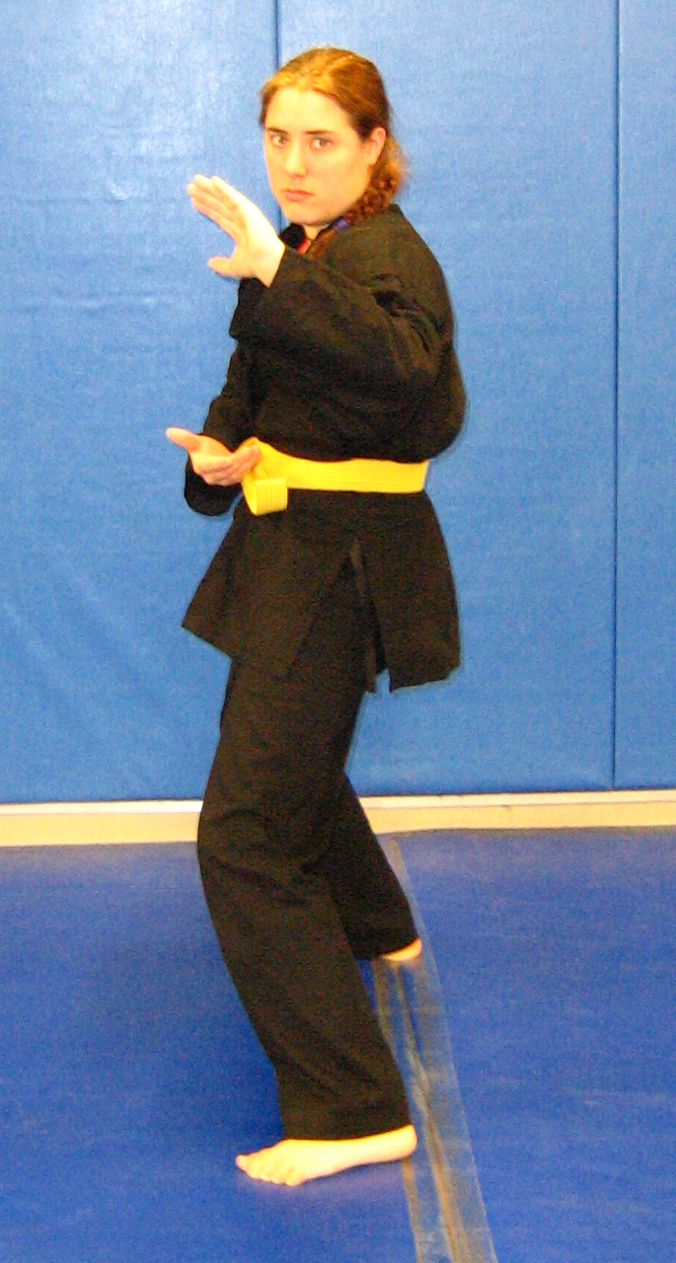
Webpage:
http://www.pitt.edu/~sorc/pittkaju
Web forum:
http://s14.invisionfree.com/Pittsburgh_Kajukenbo/index.php
Contact:
pittkaju@gmail.com

Next Practice: Tuesday, August 29 7pm-9pm in Trees Upstairs Multi-Purpose room
------------------------------------------------------------------------------------------------------------
Brazilian Jiu-Jitsu Club

The Pittsburgh Brazilian Jiu-Jitsu Club trains in the art that was established when Mitsuo Maeda, and Japanese Judo and Jiu-Jitsu master, went to Brazil and taught the son of politician Gastao Gracie, Carlos Jiu-Jitsu. Brazilian Jiu-Jitsu has emerged as the premier ground-fighting system, and is utilized by many, if not all, mixed-martial arts practitioners and competitors today. The art focuses on using judo and wrestling to take one's opponent to the ground, control his position, and use joint-locks or chokes to disable him, ending the fight.

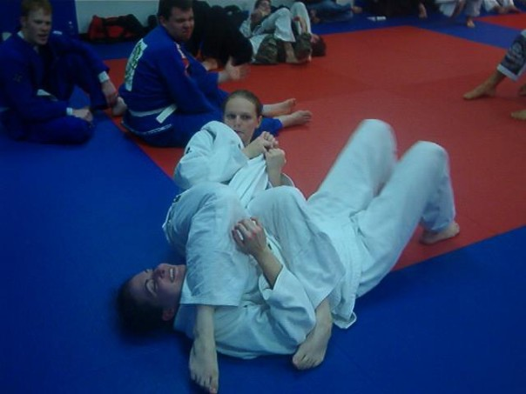

Webpage:
http://www.pitt.edu/~sorc/bjjclub
Web forum:
http://s14.invisionfree.com/Pittsburgh_BJJ_Club/index.php
Contact:
pittbjj@gmail.com

Next Practice: Friday, September 1 7pm-10pm in Trees Multi-Purpose room

