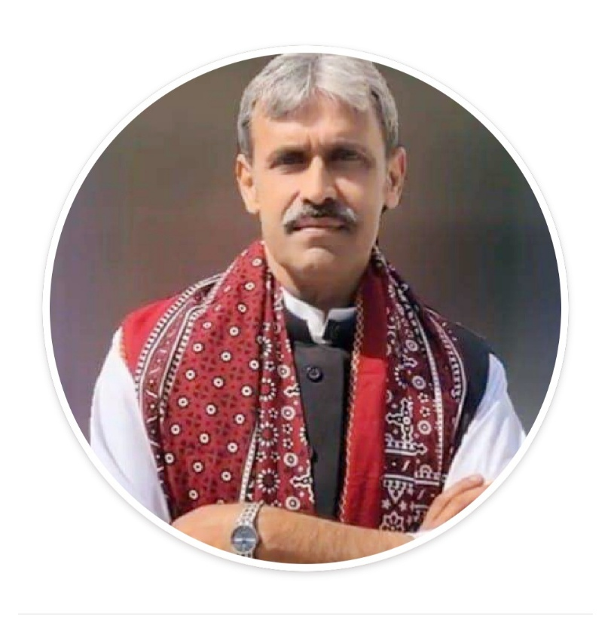
Dr. Abdul Rehman Pirzado
a public health professional from Hyderabad, Sindh, Pakistan. He is a medical graduate with postgraduate degrees in Paediatrics and Public health.
Dr. Pirzado is an expert in the fields of Public Health; Health Systems Strengthening; Maternal, Neonatal and Child Health; Reproductive Health, Nutrition; Curriculum Development; Behaviour Change Communication & Development; Pre-service & In-service education; Program Planning; Monitoring, Evaluation and Research; and Programme Management. I have more than 30 years of experience in development and humanitarian programmes in South Asia.
Since 2014 is working as freelance professional. During his thirty plus years of public health career has worked with UNFPA as RMNCH consultant, International Medical Corps as Public Health Specialist to develop training materials and webinars addressing COVID-19, World Health Organization for Malaria Program Review and Developing abridge clinical course and Editing Integrated Management of Neonatal and Childhood Illness (IMNCI) Pakistan 2019 guidelines, World Bank to develop generic guidelines for integrating Nutrition interventions in Primary Health Care Package in Pakistan, Urban Nutrition, Pre-service healthcare providers education and Nutrition Support Program, Nutrition International for developing Pakistan Universal Salt Iodizing Framework, College of Physicians and Surgeons as faculty Reproductive Health.
Dr. Pirzado has served as the Team leader Norway Pakistan Partnership Initiative (NPPI), covering ten districts of Sindh focusing RMnCAH & Nutrition, this included establishing Under5 clinics, Obstetric Skill Laboratories, Establishing centers of excellence for MnCH at public sector universities in Sindh, Pakistan, supporting the design of Students logbook, teachers manual and teaching plans for preservice medical education for LUMHS, Jamshoro.
Previously served as Program Officer MoH-UNFPA 7th Country Program to pilot strengthening RMNCAH at district level by harmonizing health, population, education, community development and district governance during this tenure piloted Mobile Service Units, Injectable Contraceptives through LHW, Life Skill Based Education, BEmONC, CEmONC, DHPMT, DTC, introduction of community midwifery in Pakistan and piloting DHIS etc .
Worked with UNICEF as Technical Coordinator Multiple Indicator Cluster Survey (MICS).
With Aga Khan University as deputy Coordinator/technical lead Tawana Pakistan Project a school nutrition program focusing on girl child using PRA techniques for community engagement.
With Department of Health, Government of Sindh as Deputy Coordinator LHW program and Deputy focal person nutrition overseeing Universal Salt Iodisation in Sindh.
With Health Services Academy Islamabad as faculty in Social and Preventive Paediatrics andIn charge field demonstration area.
With Department of Health, Government of Sindh as Trainer Medical Officer PHDC, Jamshoro Sindh as Coordinator Communicable Disease Control and focal person BSN program, merging FHT in LHV, strengthening commun8ty birth attendants, area focus approach to strengthen PHC services, curriculum development, human resource development;
With Department of Health, Government of Sindh as Lecturer community medicine, registrar Paediatrics and medical officer school health services.
Received Master of Science in Public Health (MSPH) from Health Services Academy, Quid-e-Azam University Islamabad, Pakistan.
Dr. Pirzado is qualified facilitator in IMNCI, SAM, DTPS, EPI, PCPNC, ENC, Teaching Methodologies.
He is fluent in Sindhi, Urdu and English.
His hobbies are poetry, short story writing, watching historic and natural movies, blog writing and reading.
Dr. Pirzado has e-published 69 books in Sindhi besides multiple training manuals adapted and used all over the country in areas of COVID-19,IMNCI, Communicable Disease Control, PHC, Malaria Microscopy, Health Education, Nutrition, Family Planning, Reproductive Health, Child Health Programs and interventions.
pirzado@gmail.com
https://www.facebook.com/groups/294882815022204/?ref=share_group_link

