**START TRIAGE MODULE**

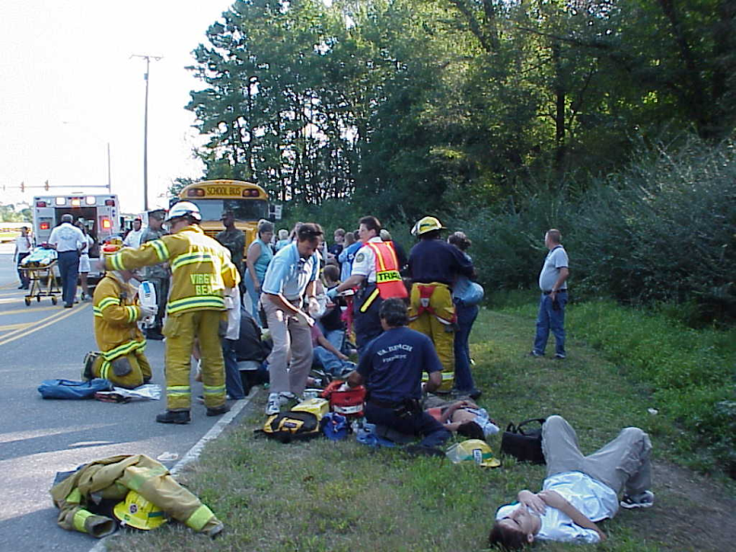

Welcome to a Public Health Disaster Preparedness module that has been developed to assist you in learning a valuable disaster management skill known as Simple Triage and Rapid Transport (START). START is a valuable pre-hospital skill that is used in events that produce mass causality incidents (MCI). It is easy to learn and can ultimately enable you the learner to impact on morbidity and mortality should a disaster incident occur.

**Why is this important?**

What would you do if you happened upon a bus accident with several injuries? Or witnessed train wreckage? Or maybe you were the first at the scene of a multicar accident. Would you know how to help? Could you work side by side with the EMS personnel to help save lives?

**Why learn S.T.A.R.T?**

As a health professional, someday be on the forefront of a disaster involving mass causalities. It may be while you are waiting for a train, while driving and or out jogging. Would you know who to help first? Sure you learned a little about hospital Triage, but what would you do if you found yourself amidst a public health emergency?

The START (Simple Triage and Rapid Transport) technique is used***internationally and is an evidence based*** technique. It is easily learned by remembering only three easy steps. In this module we teach these steps using the memory technique used for centuries, called mnemonic

and picture associations. You will be surprised how quickly and accurately you will be able to learn this START triage technique. Thank you for attending this virtual program and remember when you are done to print out your START Certificate. Learning this valuable preparedness skill you will have the potential to help hundreds at time.

Yours in nursing and education,

Marian Nowak, DNP,RN, MPH,Med,

Disaster Response Nurse and Assistant Professor UMDSNJ/ Rutgers University

Cheryl Schmidt, PHd, RN,

Disaster Materials Expert and Disaster Response Nurse

Professor at the University of Arkansas for Medical Sciences

College of Nursing

**Disclaimer**

**Our programs and information compliments the recommendations set forth by the “Essentials for Baccalaureate Education” disaster preparedness education. The ______ (name group here)------ disclaims any responsibility for any inappropriate action taken by viewers as a result of their interpretation of information provided. These modules represent a pre-hospital care information only.**

**Introduction to START Modules**

You must complete this module to receive your certificate. This program generally takes about 45 minutes to complete, however you may take as long as you like. Each person’s experience and preferred pace will determine to a large part how much time you will spend learning this valuable technique.

**Module Content**

This module will teach you adult triage known as START. It is important to note this technique is different from pediatric triage and hospital triage. Once you have completed the modules you

Can print out the START Triage Certificate.

**Step 3:**

**Print Certificate**

**Skill Objectives**

By the ends of this module you will be able to:

1. Demonstrate S.T.A.R.T.
2. Participate in a virtual disaster scenario
3. Review impact of disasters on a community.
4. Learn about volunteer opportunities
5. Receive a START Certificate

To begin simply click onto the presentation button.

***Click Here to begin***